**AI-Powered Missing Child Locator**

*Submitted for partial fulfillment of the requirements*

*for the award of*

**BACHELOR OF TECHNOLOGY**

**in**

**COMPUTER SCIENCE ENGINEERING - ARTIFICIAL INTELLIGENCE & MACHINE LEARNING**

by

**DASARI BHOVAN** - **20BQ1A4216**

**SHAIK RIZVAN** - **20BQ1A4249**

**M. NAVYA NIHARIKA** - **20BQ1A4233**

**A. SUMEDHA** - **20BQ1A4203**

Under the guidance of

**Mr. B. PARDHA SARADHI,** M. Tech, Asst. Prof.



**DEPARTMENT OF COMPUTER SCIENCE** **ENGINEERING – ARTIFICIAL INTELLIGENCE & MACHINE LEARNING**

**VASIREDDY VENKATADRI INSTITUTE OF TECHNOLOGY**

Permanently Affiliated to JNTU Kakinada, Approved by AICTE

Accredited by NAAC with ‘A’ Grade, ISO 9001:2008 Certified

NAMBUR (V), PEDAKAKANI (M), GUNTUR – 522 508

Tel no: 0863-2118036, url: www.vvitguntur.com

April 2024

**VASIREDDY VENKATADRI INSTITUTE OF TECHNOLOGY**

Permanently Affiliated to JNTUK, Kakinada, Approved by AICTE

Accredited by NAAC with ‘A’ Grade, ISO 9001:20008 Certified

Nambur, Pedakakani (M), Guntur (Gt) -522508

**DEPARTMENT OF COMPUTER SCIENCE ENGINEERING - ARTIFICIAL INTELLIGENCE & MACHINE LEARNING**

**CERTIFICATE**

This is to certify that this **Project Report** is the bonafide work of **Mr. D. Bhovan, Mr. Sk. Rizvan, Ms. M. Navya Niharika, Ms. A. Sumedha**, bearing Reg. No. **20BQ1A4216, 20BQ1A4249, 20BQ1A4233, 20BQ1A4203** respectivelywho had carried out the project entitled **“Ai – Powered Missing Child Locator "** under our supervision.

**Project Guide Head of the Department**

(Mr. B. Pardha Saradhi**,** Asst. Professor) (Dr. K. Suresh Babu, Professor)

**Submitted for Viva voce Examination held on ____________________________**

**Internal Examiner External Examiner**

**DECLARATION**

We, Mr. D. Bhovan, Mr. Shaik Rizvan, Ms. M. Navya Niharika, Ms. A. Sumedha , hereby declare that the Project Report entitled **“Ai – Powered Missing Child Locator”** done by us under the guidance of Mr. B. Pardha Saradhi, M. Tech, Asst. Professor, Computer Science Engineering - Artificial Intelligence & Machine Learning at Vasireddy Venkatadri Institute of Technology is submitted for partial fulfillment of the requirements for the award of Bachelor of Technology in Computer Science Engineering - Artificial Intelligence & Machine Learning. The results embodied in this report have not been submitted to any other University for the award of any degree.

DATE :

PLACE :

**SIGNATURE OF THE CANDIDATE (S)**

**ACKNOWLEDGEMENT**

We take this opportunity to express my deepest gratitude and appreciation to all those people who made this project work easier with words of encouragement, motivation, discipline, and faith by offering different places to look to expand my ideas and helped me towards the successful completion of this project work.

First and foremost, we express my deep gratitude to **Shri. Vasireddy Vidya Sagar**, Chairman, Vasireddy Venkatadri Institute of Technology for providing necessary facilities throughout the B. Tech programme.

We express my sincere thanks to **Dr. Y. Mallikarjuna Reddy**, Principal, Vasireddy Venkatadri Institute of Technology for his constant support and cooperation throughout the B. Tech programme.

We express my sincere gratitude to **Dr. K. Suresh Babu**, Professor & HOD, Computer Science Engineering - Artificial Intelligence & Machine Learning, Vasireddy Venkatadri Institute of Technology for his constant encouragement, motivation and faith by offering different places to look to expand my ideas.

We would like to express my sincere gratefulness to our Guide **Mr. B. Pardha Saradhi,** Asst. Professor, Computer Science Engineering- Artificial Intelligence & Machine Learning for his insightful advice, motivating suggestions, invaluable guidance, help and support in successful completion of this project.

We would like to express our sincere heartfelt thanks to our Project Coordinator **Mr. N. Balayesu,** Asst. Professor, Computer Science Engineering - Artificial Intelligence & Machine Learning for his valuable advices, motivating suggestions, moral support, help and coordination among us in successful completion of this project.

We would like to take this opportunity to express my thanks to the **Teaching and Non-Teaching** Staff in the Department of Computer Science Engineering - Artificial Intelligence & Machine Learning, VVIT for their invaluable help and support.

**Name (s) of Students**

D. Bhovan [20BQ1A4216]

Sk. Rizvan [20BQ1A4249]

M. Navya Niharika [20BQ1A4233]

A. Sumedha [20BQ1A4203]

**TABLE OF CONTENTS**

**CH No Title Page No**

Contents i

List of Figures iii

Nomenclature iv

Abstract v

**1 INTRODUCTION**

1.1 Background and Need for the Project 1

1.2 Objectives of the AI-Powered Missing Child Locator 1

1.3 Challenges in Current Missing Child Location Methods 2

1.4 Advantages of AI and Facial Recognition Technology 3

1.5 Analysis on Missing Child Locator Systems 4

1.6 Innovation in Facial Recognition Technologies 6

1.7 Role of Community and Technology in Child Safety 8

1.8 Privacy and Ethical Considerations in the Use of Facial Recognition 9

1.9 Overview of the Proposed System's Architecture and Components 11

1.10 Importance of a Unified Database for Missing Children 13

1.11 Potential Impact on Law Enforcement and Child Protection Agencies 15

**2 REVIEW OF LITERATURE** 17

**3 PROPOSED SOLUTION**

3.1 Overview of the Proposed Solution 19

3.2 Description of Technologies Used (MTCNN, Face net, SVM) 19

3.3 System Architecture and Workflow 22

3.4 Data Collection and Privacy Measures 25

3.5 Integration with Existing Child Safety Networks 27

3.6Dataset Description and Preparation28

**4 IMPLEMENTATION**

4.1 Facial Recognition Technologies 30

4.2 Dataset Preparation and Benchmarking 31

4.3 Development Tools and Environment 33

4.4 Security and Privacy Measures 35

4.5 User Interface and Experience 36

4.6 Monitoring and Updates 37

4.7 System Design 39

4.8 Android app integration 46

**5 RESULTS 54**

**6 CONCLUTION AND FUTURE SCOPE**  **55**

**7**  **REFERENCES**  **56**

**APPENDIX 5**7

Research Paper Publication Certificate 57

Published Article in the Journal 61

**LIST OF FIGURES**

**Figure No Figure Name Page No**

1.5 Facial Recognition 5

1.7 Role of Community and Technology in Child 8

1.8 Bias and Fairness in Algorithmic Decision-Making 10

1.10 Architecture of the model 14

1.11.1 Recovered Statistics 15

1.11.2 Strengthening Community Efforts 16

3.2.1 Multi-task Cascaded Convolutional Networks 20

3.2.2 Face Net Network Architecture 21

3.2.3 Support Vector Machine 22

3.3 Workflow of Missing Child Tracker 25

4.1.3 Facial Recognition Technologies 31

4.2.3 Comparison with State-of-the-Art Models 33

4.7.1 Use Case Diagram 40

4.7.2 Class Diagram 41

4.7.3 Sequence Diagram 42

4.7.4 Activity Diagram 43

4.7.5 Component Diagram 44

4.7.6 Deployment Diagram 44

4.7.7 State Chart Diagram 45

4.8.1 Home page analytics depicted visual Screen 47

4.8.2 Add Emergency Contacts Screen 48

4.8.3 Report Missing Child Screen 49

4.8.4 Facial Recognition Matching Screen 50

4.8.5 View Reports Screen 51

4.8.6 View Profile Screen 52

4.8.7 Interactive Map Display Screen 53

5.1 Accuracy of Different Models 54

**NOMENCLATURE**

MTCNN Multi-task Cascaded Convolutional Networks

SVM Support Vector Machine

YLFW Young Labelled Faces in the Wild

AI Artificial Intelligence

ML Machine Learning

**ABSTRACT**

An innovative mobile app that helps people locate missing children by utilizing the "Track the Missing Child" database maintained by the Women and Child Development (WCD) Ministry and facial recognition technology developed by Delhi Police. The recommended method uses pioneering face recognition technologies, including Multi-task Cascaded Convolutional Networks (MTCNN), Facenet, and Support Vector Machine (SVM), to increase the accuracy and efficiency of child identification.

The software's main goal is to let users snap a photo of an unattended child and utilize facial feature analysis to find out if the child has gone. To recognize faces at the beginning of the process, the application employs MTCNN, to extract features using Facenet, and to classify images using SVM. When combined, these components provide a potent facial recognition system that will consistently match the captured features of the face with the "Track the missing child" database. Unlike other methods, the proposed approach provides individuals with an easy-to-use interface that allows them to participate actively in the identifying process. Innovative facial recognition technology ensures precise and timely outcomes, even in challenging circumstances. The system additionally prioritizes ethical and privacy concerns, ensuring the safe processing of sensitive data.

This project uses innovative facial recognition technology to address a major societal issue, bridging the gap between technology and social responsibility. The public and law enforcement organizations can collaborate to safeguard children's safety and wellbeing while also This project uses innovative facial recognition technology to address a major societal issue, bridging the gap between technology and social responsibility. The public and law enforcement organizations can collaborate to safeguard children's safety and wellbeing while also improving child identification accuracy by utilizing Facenet, MTCNN, and SVM technologies.

**Keywords** : AI-Powered Missing Child Locator, Artificial Intelligence, Facial Recognition, MTCNN, FaceNet, SVM, Mobile Application, Child Safety, Public Engagement, Law Enforcement, Track the Missing Child Database.

**CHAPTER 1**

**INTRODUCTION**

**1.1 Background and Need for the Project**

The safety and security of children are now a top priority globally in the digital era. Families and communities experience distress and panic as many children disappear each year. Traditional ways of finding missing children, like posters, media alerts, and manual searches, have substantial drawbacks. These methods are slow, may not reach everyone effectively, and can lead to delays. There is a pressing demand for new and creative solutions to address this issue swiftly.

Artificial Intelligence (AI) has the ability to revolutionize the quest for lost children. AI-driven tools, specifically facial recognition systems, provide a glimmer of optimism. These tools can rapidly examine extensive data, detect subtle patterns that humans may miss, and instantly compare discovered children with missing persons reports. The project known as "AI-Powered Missing Child Locator" seeks to utilize these functions via a mobile app that links with the "Track the Missing Child" database. This integration allows for prompt identification and locating efforts by both civilians and law enforcement groups.

This initiative is based on a thorough grasp of the difficulties involved in finding missing children. By utilizing advanced AI technologies such as Multi-task Cascaded Convolutional Networks (MTCNN), Facenet, and Support Vector Machine (SVM), it presents a solution that is not only original but also adaptable and attuned to the pressing demands of society. The primary objective is to decrease the duration required to find a missing child, thereby lessening the possible distress and suffering endured by both the child and their family.

**1.2 Objective of the AI – Powered Missing Child Locator:**

The project called AI-Powered Missing Child Locator is created to use advanced artificial intelligence to improve the speed, precision, and effectiveness of finding missing children. Its goal is to connect technology with social welfare to develop a tool that can make a positive difference in the lives of families and communities globally. The aims are varied, concentrating on technological progress as well as social influence, teamwork, and creativity.

**Improve Search Effectiveness**: Use artificial intelligence, specifically facial identification techniques such as Multi-task Cascaded Convolutional Networks (MTCNN), Facenet, and Support Vector Machine (SVM), to significantly decrease the duration required to find a lost child after they have been reported missing.

**Enhance Matching Accuracy**: Utilize advanced AI algorithms to enhance the accuracy of matching located children with records in the "Track the Missing Child" database, reducing false identifications that may result in resource wastage and distress for families.

**Enable immediate sharing of data**: Develop a system that enables the real-time exchange of information among the community, police departments, and organizations dedicated to child safety, guaranteeing that information on missing children is current and easily obtainable.

Broaden the database for worldwide access by striving to increase the size of the "Track the Missing Child" database beyond just a national scale to an international level. Recognize that child disappearances are a concern on a global scale and develop a resource that can be utilized globally with significant effects.

**Inform and increase awareness**: In addition to the app's main purpose of finding lost children, utilize the platform to inform the community about safety measures for children, methods for prevention, and ways to assist families of missing children. This will help create a safer environment for all children.

The goals of the AI-Powered Missing Child Locator project work together to guide it towards its main aim: using technology to create a real impact on the pressing and emotional problem of missing children. Through reaching these goals, the project hopes to not just bring families back together and prevent tragedies, but also establish a model for how technology can be used for positive purposes, encouraging more advancements in the field where artificial intelligence meets social well-being.

**1.3 Challenges in Current Missing Child Location Methods:**

The problem of missing children is complex and heartbreaking, with current search methods facing many challenges that affect their effectiveness. The AI-Powered Missing Child Locator project aims to address these challenges through technological innovation.

**Lack of Timely Information**: One of the most significant challenges in locating missing children is the delay in disseminating information. The critical first hours after a child goes missing are often lost due to slow reporting processes and bureaucratic red tape.

**Fragmented Databases**: The absence of a unified, accessible database for missing children complicates search efforts. Different agencies and organizations maintain separate records, leading to information silos that impede the quick cross-referencing of data.

**Limited Public Engagement**: Traditional methods often fail to effectively engage the public in search efforts. While community alerts and media broadcasts are used, they do not actively involve citizens in a way that utilizes their collective power to observe and report.

**Reliance on Manual Processes**: Many current search efforts are manual and labor-intensive, from distributing flyers to organizing physical search parties. These methods are not only resource-heavy but also have limited reach and effectiveness.

**Inaccurate Identification**: Identifying found children and matching them with missing reports is fraught with inaccuracies. Physical descriptions and photographs can be unreliable, especially if the child has been missing for a long period.

**Cross-Jurisdictional Issues**: Children who are missing can easily be moved across state or national boundaries, complicating search efforts. The lack of a coordinated approach between different jurisdictions further delays recovery efforts.

**Privacy and Ethical Concerns**: Balancing the urgency of finding missing children with the need to respect privacy rights and ethical standards presents a challenge. Ensuring that search methods do not infringe on personal freedoms is a complex issue.

**Digital Divide**: Not all communities have equal access to digital platforms and technologies that could aid in search efforts. This digital divide means that certain populations might be underserved by technological solutions. Without equitable access to digital platforms and technologies, efforts to utilize advanced tools like the AI-Powered Missing Child Locator can fail to serve all segments of society equally, potentially leaving vulnerable populations without the benefits of these life-saving innovations.

**1.4 Advantages of AI and Facial Recognition Technology:**

The integration of Artificial Intelligence (AI) and Facial Recognition Technology revolutionizes the search for missing children by offering unparalleled advantages that surpass traditional search methods. This innovative approach not only accelerates the identification and location process but also enhances accuracy, broadens the scope of search efforts, and fosters global collaboration.

**1.Efficiency and Speed**: AI's ability to quickly process vast amounts of data dramatically reduces the time it takes to match found children with missing reports. This speed is crucial in the critical initial hours and days following a child's disappearance, significantly increasing the chances of a safe recovery.

**2.Precision in Identification**: Facial recognition technology offers a high degree of accuracy in identifying missing children from photos or video footage. By analyzing specific facial features, it minimizes false positives, ensuring that resources are focused and families are spared unnecessary anguish.

**3.Global Reach and Collaboration**: AI's scalability enables the creation of a comprehensive, global database accessible to various organizations and law enforcement agencies worldwide. This facilitates seamless cross-border collaboration, essential for tracking missing children who may have been moved across jurisdictions.

**4.Community Engagement**: The deployment of a user-friendly mobile app empowers the public to participate actively in search efforts. This engagement expands the network of eyes on the ground, greatly increasing the likelihood of locating missing children through community reports and contributions.

**5.Continuous Operation**: Unlike manual operations that may be limited by time and resources, AI systems can operate continuously. This 24/7 functionality ensures that the search for missing children is relentless, enhancing the prospects for timely recoveries.

**6.Data-Driven Insights**: Beyond immediate search efforts, AI provides insights into patterns of disappearances, which can inform preventative measures and strategies to reduce future incidents. This analytical capability is invaluable for understanding and mitigating risks to children.

**7.Ethical and Privacy Considerations**: Implementing AI and facial recognition in the search for missing children is conducted with a deep commitment to ethical standards and privacy. Measures are in place to protect personal data, ensuring that technology serves as a force for good without compromising individual rights.

**1.5 Analysis on Missing Child Locator Systems:**

Researching the impact of AI and facial recognition in missing child locator systems involves a deep review of different perspectives from existing literature. This analysis aims to blend old techniques with new technologies, leading to improved child safety and rescue efforts.

**Advancing Trends in Locator Technologies:** Moving from analog to digital, and now to AI-based systems, shows a big advancement in locating missing children. The focus has shifted from community networks and search teams to digital alerts and online databases. Each improvement enhances effectiveness and expands reach. Yet, the challenge remains in finding a universally successful solution due to time limits and logistical hurdles in missions to save missing children.

**Facial Recognition and Artificial Intelligence:** AI and facial recognition technology in locating missing children represent more than just progress in technology; it signals a shift in how society approaches child safety. These tools can swiftly analyze and compare images from vast databases, offering hope when time is of the essence. Research shows that AI can overcome obstacles and streamline search efforts, leading to faster identification and rescue of missing children.

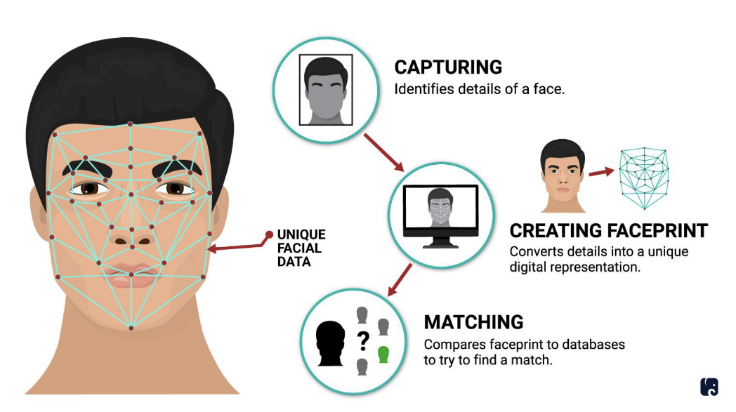

Fig 1.5: Facial Recognition

**Ethical Considerations and Challenges:** Maintaining a balance between promptly locating missing children and protecting personal rights while maintaining public trust is a challenging task. Scholars suggest establishing ethical guidelines and operational procedures to handle this balance effectively.

The evolution from manual searches to AI-powered systems marks a significant leap forward, offering hope and renewed vigor in the mission to reunite missing children with their families.

**Challenges**

1. Data Privacy and Security Concerns

2. Ethical Use of Surveillance and Facial Recognition

3. Accuracy and Reliability of AI Algorithms

4. Integration and Compatibility Across Systems

5. Public Acceptance and Trust in AI Technologies

6. Accessibility and Digital Divide

7. Cross-Jurisdictional Legal and Regulatory Challenges

8. Dependence on Quality and Diversity of Data

9. Managing False Positives and Negatives

10. Continuous Technological Adaptation and Updates

**The Importance of Data in Influencing Success:** The effectiveness of AI-driven systems depends on the quality and range of the data they analyze. Research highlights the significance of varied, thorough datasets for teaching algorithms, so they can precisely identify children from different backgrounds and situations. This emphasizes the requirement for teamwork in constructing and managing large databases that utilize information from public, private, and government sources to improve identification precision.

**Working together in a unified manner:** The literature often emphasizes the need for a comprehensive strategy that utilizes the advantages of AI and facial recognition in a joint framework. Bringing together technology, community involvement, and cooperation between different agencies holds promise for establishing an effective system to find missing children. This collaborative effort goes beyond just merging technologies, involving shared procedures, mutual information sharing, and coordinated actions that go beyond geographical and jurisdictional limits.

**Innovation and Adjustment in the Future Terrain:** The literature suggests a promising future where ongoing innovation and flexible technologies transform the potential in child rescue initiatives. New studies are exploring self-teaching AI systems that learn from search results, decentralized blockchain solutions for safe data exchange, and the use of augmented reality in search missions. These developments aim to improve existing capacities and introduce fresh approaches to safeguarding children in an ever-evolving digital landscape.

**A Coming Together of Hope and Technology:** The extensive examination of literature on AI and facial recognition in systems for locating missing children envisions a future where technology supports humanity's noblest objectives. As these tools advance in complexity and usage, the shared goal to protect the world's children progresses. Despite obstacles and ethical discussions, progress is guided by a dedication to creativity, cooperation, and a constant attention to the welfare of children. Within this blend of optimism and technology is the potential for a more secure future for everyone.

**1.6 Innovation in Facial Recognition Technologies:**

The advancement of facial recognition technology stands at the forefront of improving missing child locator systems. These innovations not only enhance the ability to accurately identify individuals across diverse environments and conditions but also address critical challenges such as privacy concerns and data integrity.

**Deep Learning Enhancements:** Recent strides in deep learning, especially convolutional neural networks (CNNs), have significantly boosted facial recognition accuracy. These enhancements allow for sophisticated feature extraction from images, facilitating accurate identification even under variable conditions such as lighting, orientation, and facial obstructions.

**Computational Power Advances:** The exponential growth in computational capabilities has enabled the processing of extensive facial image datasets at unprecedented speeds. This advance is crucial for real-time applications in missing child locator systems, allowing for the swift comparison of newly reported cases against extensive databases of missing children.

**Image Processing Improvements:** Technological advances in image processing have dramatically improved the ability of facial recognition systems to work with low-resolution images. Techniques for enhancing image quality and extracting usable data from partially obscured faces have expanded the applicability of facial recognition in real-world scenarios.   
The strides made in image processing technology have notably expanded facial recognition's utility by enabling the system to effectively interpret and utilize even low-quality or partially.

**Cloud Computing and Big Data Integration:** Leveraging cloud computing and big data analytics has transformed facial recognition technologies, offering scalable, accessible, and constantly updated systems. This integration ensures that facial recognition databases can be quickly expanded and updated, enhancing the global search for missing children.

**Mobile Technology Deployment:** The deployment of facial recognition technology on mobile platforms has made it more accessible, allowing for broader public participation in missing child search efforts. This innovation empowers individuals to contribute actively to locating missing children by using mobile applications to report sightings and share information.

**Privacy and Security Innovations:** In response to growing concerns over privacy and data security, facial recognition technologies have incorporated advanced encryption and anonymization techniques. These innovations help protect sensitive data, ensuring that the use of facial recognition in missing child searches respects individual privacy and adheres to regulatory standards.

**Interoperability and Standardization Efforts:** Efforts to standardize facial recognition technologies and ensure interoperability across different platforms and jurisdictions are crucial for facilitating international cooperation in missing child searches. Standardization allows for the seamless exchange of information and coordination of efforts across borders, enhancing the global reach of search operations.

By embracing these advancements, such systems are positioned to offer more effective, efficient, and globally coordinated responses to one of society's most pressing challenges. The future of missing child searches lies in harnessing these technologies, ensuring they are used responsibly and ethically to protect and recover vulnerable children around the world.

**1.7 Role of Community and Technology in Child Safety** **:**

The combination of community involvement and technology strengthens child safety efforts. Society is working on protecting vulnerable members through communal awareness and advanced tools like the AI-Powered Missing Child Locator system.

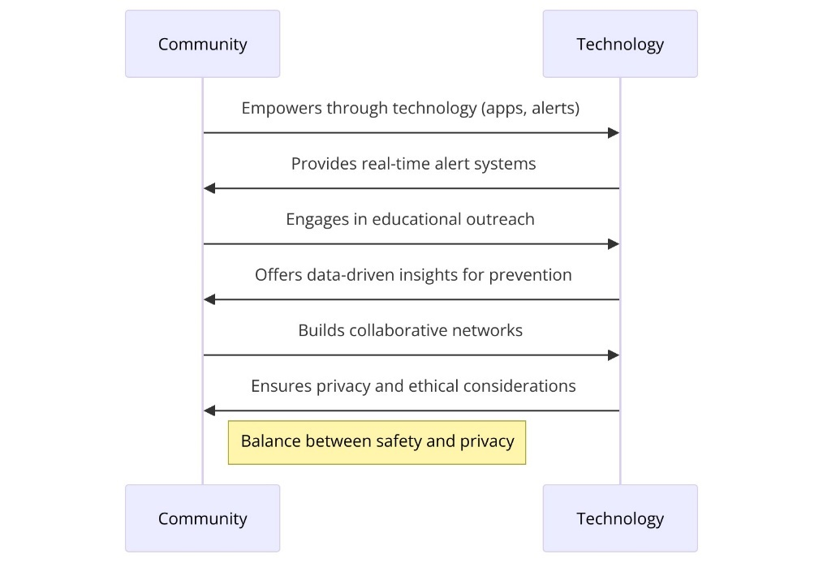

Fig 1.7: Role of Community and Technology in Child Safety

1. **Empowering the Community Through Technology**

* **Leveraging Collective Vigilance**: The key to child safety programs is community involvement. Providing citizens with tools like facial recognition mobile apps makes finding missing children everyone's responsibility. This strategy uses the community's presence and observation skills, turning all smartphone users into potential protectors.
* **Educational Outreach and Awareness**: Technology is used to share important information about child safety and missing children. Digital educational programs help engage the community in discussions to increase awareness and promote a culture of vigilance and responsibility for protecting children.

**2.Enhancing Response Capabilities with AI**

* **Real-Time Alert Systems**: By combining AI with local alert systems, information about missing children can quickly spread. These customized alerts inform specific areas and prompt immediate action from the community, reducing search time for better results.
* **Data-Driven Insights for Prevention**: AI algorithms analyze patterns and trends from reported cases to provide insights into safety risks and strategies. By sharing these findings, technology helps guide policy-making and community practices to enhance child safety. By disseminating these data-driven insights, technology plays a crucial role in informing policy-making and shaping community practices, ultimately contributing to the enhancement of child safety measures on a broader scale.
* Top of Form

**3.Building Collaborative Networks**

* **Strengthening Ties Between Law Enforcement and Communities**: Technology integration in child safety programs enhances cooperation between law enforcement and communities. Digital platforms enable better communication, reporting, and coordination to establish trust and provide a united approach to child safety issues.**Global Community of Child Protectors**: Technological progress eliminates geographical boundaries, forming a global network focused on child safety. This connected community exchanges resources and knowledge to enhance the ability to safeguard children worldwide.

**4.Privacy and Ethical Considerations**

* **Balancing Safety with Privacy**: Technology is increasingly important for improving child safety in communities. It is crucial to find a balance between surveillance and privacy. Ethical use of tools like facial recognition requires clear policies, consent procedures, and data protection to protect individuals' rights while ensuring child safety.
* **Community-Driven Governance**: Community involvement in governing technology use for child safety is crucial. Including community representatives in decision-making aligns technological initiatives with societal values and ethics, promoting ownership and accountability among stakeholders.

The collaboration of community and technology is a strong factor in child safety. By combining community awareness with AI and other technologies, we can create a safer environment for children. This partnership improves child protection efforts and shows dedication to a safer world for future generations.

**1.8 Privacy and Ethical Considerations in the Use of Facial Recognition:**

Facial recognition technology, especially in sensitive areas like missing child locators, raises privacy and ethical concerns. It is crucial to address these issues directly to ensure its use maintains high standards of privacy, consent, and ethics.

**Upholding Privacy in Surveillance**

Facial recognition for finding missing children raises privacy concerns. It's crucial to use surveillance in a way that respects privacy by following strict data protocols, anonymizing data, and conducting facial scans with a clear legal basis.

**Strategies**:

* Limiting the scope of surveillance to contexts directly related to child safety and recovery efforts.
* Employing data minimization principles to ensure only necessary data is collected and retained. Implementing robust access controls to restrict data access to authorized personnel only, preventing unauthorized use.

**Consent and Data Usage:**

Ethical data usage, especially with biometric data such as facial images, relies heavily on consent. Obtaining permission for using personal images in missing child locator systems, specifically from guardians or family members of the missing child, must be handled sensitively and transparently.

**Strategies**:

* Developing clear consent protocols that inform individuals about how their data will be used, stored, and protected.
* Providing options for individuals to withdraw consent and have their data removed from systems where feasible.

**Bias and Fairness in Algorithmic Decision-Making:**

Facial recognition technologies are under scrutiny for biases that can impact different demographics. Training these systems on diverse datasets to recognize faces accurately across various groups is crucial for ethical use.

**Strategies**:

* Rigorous testing and validation of algorithms to identify and mitigate biases.
* Continuous monitoring and updating of systems to improve accuracy and fairness across diverse populations.

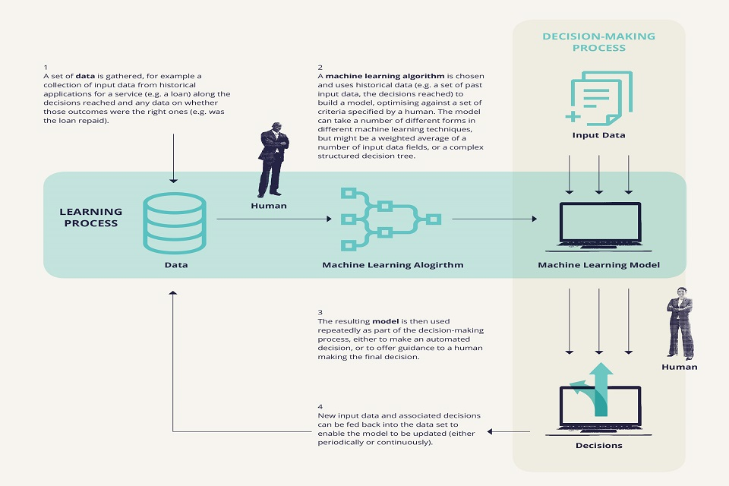

Fig 1.8: Bias and Fairness in Algorithmic Decision-Making

**Accountability and Transparency:**

Ensuring trust in facial recognition technology requires being transparent about its use, capabilities, limitations, operation, privacy safeguards, and ethical measures.

**Strategies**:

* Publishing transparency reports detailing the use, effectiveness, and impact of facial recognition technologies in missing child recovery efforts.
* Establishing oversight mechanisms, such as ethics boards or review committees, to evaluate and guide the deployment of these technologies.

**Safeguarding Against Misuse:**

The potential for misuse of facial recognition technologies, whether through unauthorized access or inappropriate applications, poses significant risks. Implementing robust security measures and clearly defining acceptable uses are crucial steps in mitigating these risks.

**Strategies**:

* Enforcing strong cybersecurity protocols to protect data from unauthorized access or breaches.
* Defining clear legal and policy frameworks that outline acceptable uses and prohibitions against misuse.

To ethically use facial recognition technology in missing child locator systems, a comprehensive approach focusing on privacy, consent, fairness, and transparency is crucial. By carefully considering these aspects in advance, we can utilize this technology for child safety while upholding ethical and privacy values.

**1.9 Overview of the Proposed System's Architecture and Components:**

The system is designed to improve finding missing children by combining AI and facial recognition. It has a strong, scalable structure for quick, accurate, secure data processing. Here are the main components of the system.

**Core System Architecture**

* **Data Collection Module**: This module collects input from public reports, social media, and law enforcement databases in a privacy-conscious way with proper consent.
* **Facial Recognition Engine**: The facial recognition process can be conceptualized as a function that maps input images to identity matches based on extracted features:

**F(I)→M**

Where:

**F** represents the facial recognition function.

**I** is the input image from the data collection module.

**M** is the match outcome, indicating a potential match with identities in the database

* **AI Analysis and Matching Module**: The matching algorithm might involve calculating the similarity between the feature vector of the input image and those in the database, selecting the highest similarity scores as potential matches

***S*(*Fi*​, *Dj*​) ≥ *θ***

Where:

***S*** is the similarity function, measuring the closeness between two facial feature vectors.

***Fi***​ is the feature vector extracted from the input image.

***Dj***​ is a feature vector of a face in the database.

***θ*** is the threshold value for considering a match valid.

* **Database Management System (DBMS)**: A database that is both secure and able to expand in size holds important information, such as comprehensive profiles of lost children and past case details. This database allows for quick searching and retrieval of data to help with the process of finding matches.

***Q*(*S*,*θ*)→{*Pk*​}**

* **Alert and Notification System**: When there is a positive match, the system creates notifications for the appropriate officials and, if needed, the person who made the initial report. This feature guarantees prompt communication using different methods like email, text messages, or app alerts.

**if *S*(*Fi*​,*Dj*​)≥*θ* then TriggerAlert(*Pk*​)**

**Supporting Infrastructure**

* **Cloud Computing Platform**: The system is hosted on a cloud computing platform, providing scalability, reliability, and high availability. This infrastructure supports the handling of large data volumes and intensive processing tasks without compromising performance.

***C*(*L*)→*R***

* **Mobile Application**: A user-friendly mobile app serves as the primary interface for public engagement. It allows users to report sightings, upload photos, and receive alerts. The app is designed with a focus on accessibility and ease of use to encourage widespread participation.
* **Security and Privacy Layer**: Embedded throughout the system's architecture is a comprehensive security and privacy framework. This includes data encryption, anonymization techniques, and strict access controls to protect sensitive information and ensure compliance with data protection regulations.
* **Analytics and Reporting Dashboard**: For oversight and continuous improvement, the system includes an analytics dashboard. This tool provides insights into system performance, match accuracy, user engagement metrics, and other key indicators.

**Integration Capabilities**

* **API Gateway**: To facilitate integration with external systems, such as law enforcement databases and social media platforms, the system includes a secure API gateway. This gateway enables controlled data exchange, extending the system's reach and effectiveness.

The structure and parts of the suggested system are created to utilize AI and facial recognition technology effectively and morally. Through merging sophisticated technical features with an emphasis on user interaction and data protection, the system seeks to transform the process of finding missing children, making it quicker, more precise, and available to all parties concerned.

**1.10 Importance of a Unified Database for Missing Children:**

Creating a single database for lost children is crucial for improving the speed and success of finding and reuniting them with their families. This central storage facility acts as a vital tool for different groups, such as police departments, child protection groups, and the general public, offering an inclusive and user-friendly source of data on missing children incidents.

A centralized information system combines data from various sources, removing isolated data pockets that can impede search activities. With a single source of information, organizations can easily retrieve current data, making it easier to identify and find missing children.

* **Improved Data Precision and Uniformity**: Centralizing the data ensures that information is consistent and accurate across various regions and departments. This standardization is essential for the dependability of search procedures, as inaccuracies in data might cause setbacks and errors in identification.
* **Enhanced Search and Matching Effectiveness**: Utilizing sophisticated algorithms and artificial intelligence tools, a consolidated database can rapidly analyze extensive data to pinpoint potential connections between reported sightings and available reports of missing children. This functionality significantly speeds up the identification process, which is essential in the time-critical context of child rescue operations.

Enhanced cooperation among various regions and nations is facilitated by a central database, which enables better collaboration in situations concerning lost children that extend across boundaries. This integrated platform fosters smooth information sharing and teamwork among global organizations, ultimately bolstering the international endeavour to combat cases of child disappearance. The community is empowered to participate in the search for lost children by linking the centralized database with public platforms and mobile applications. This involvement improves search endeavours by expanding their reach and impact through the collective vigilance of society.

The data gathered in a central database can provide important insights on trends and patterns related to child disappearances, which can be utilized to develop preventive strategies, policies, and awareness campaigns aimed at decreasing the incidence of missing children.

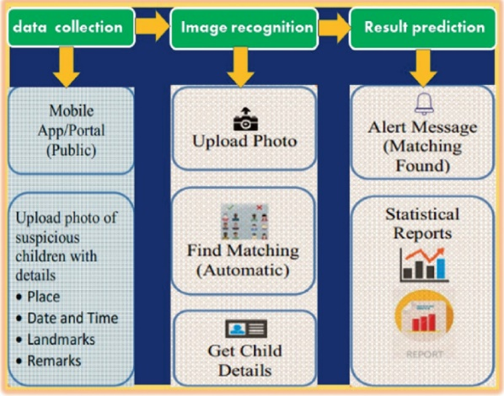

Fig 1.10: Architecture of the model

Ensuring adherence to privacy and ethical standards is essential in the development and management of a consolidated database, despite the many benefits it provides. Strict compliance with privacy laws and ethical values is crucial. Thoroughly anonymizing data, implementing secure access protocols, and transparently communicating about data usage are key in maintaining public confidence and protecting individual rights.

Developing a unified database for missing children is essential within the broader framework of child protection efforts. This repository will provide a comprehensive, accurate, and easy-to-use platform for information sharing and collaborative work. It enhances the effectiveness of locating lost children and aids in identifying trends in disappearances, facilitating proactive measures. Given technological progress and societal collaboration, this database is becoming ever more critical in safeguarding the well-being of children worldwide.

In essence, the development of a comprehensive database marks a significant leap forward in the global fight against child disappearance, enhancing both the immediate response to such incidents and the long-term strategies for prevention and awareness. Through concerted efforts and the leveraging of cutting-edge technology, the vision of a safer world for children is increasingly within reach, underscoring the database's critical role in protecting the most vulnerable members of society.

**1.11 Potential Impact on Law Enforcement and Child Protection Agencies:**

The introduction of a consolidated database paired with AI and facial recognition tools marks a new era for law enforcement and organizations focused on child welfare. This advancement is expected to have a profound effect on these entities by improving their abilities, facilitating teamwork, and promoting a data-centric approach to safeguarding children.

**Streamlined Operations and Rapid Response**

The unified database facilitates an unprecedented level of operational efficiency, allowing agencies to access and share critical information instantaneously. This capability is crucial for rapid response in missing child cases, where every moment counts.

* **Impact**: Reduced response times and more efficient utilization of resources, leading to quicker mobilizations in search and rescue operations.

**Enhanced Identification and Recovery Rates**

AI-powered facial recognition technology introduces a level of precision in identifying missing children from images and video footage, significantly increasing the likelihood of successful recoveries. This technology can match faces against the vast dataset of missing children with remarkable accuracy, even in challenging conditions. The integration of such technology into child protection efforts marks a pivotal advancement, enhancing the efficiency and effectiveness of recovery operations and offering new hope in the search for missing children.

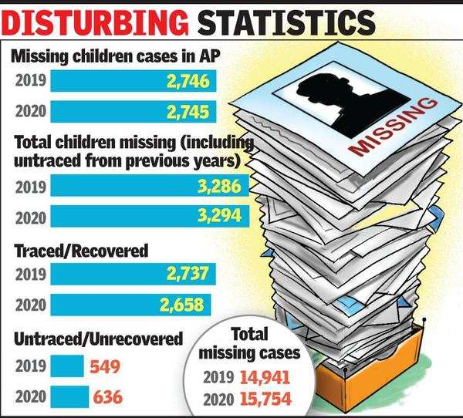

Fig 1.11.1 : Recovered Statistics

* **Impact**: Higher recovery rates of missing children, with AI providing the ability to identify individuals even after significant time has passed or their appearance has changed.

**Facilitation of Cross-Jurisdictional Efforts**

A unified database eliminates informational chaos, enabling seamless information sharing across jurisdictions and borders. This is particularly impactful for cases that extend beyond local or national boundaries, facilitating a coordinated global response.

* **Impact**: Enhanced collaboration leads to more cohesive and effective search efforts, breaking down barriers that previously complicated cross-jurisdictional cases.

**Empowerment Through Data-Driven Insights**

Aggregating data within a unified system allows for advanced analytics, offering insights that can guide strategic decisions, policy development, and preventive measures. Agencies can analyze trends, identify risk factors, and allocate resources more effectively.

* **Impact**: Strategic and informed decision-making processes, underpinned by comprehensive data analysis, leading to more targeted and effective child protection strategies.

**Strengthening Community Engagement**

Integrating public-facing platforms with the unified database not only empowers the community to contribute to child safety efforts but also builds trust between the public and law enforcement agencies. This mutual trust is essential for the collaborative nature of child protection work.

* **Impact**: Increased public participation in reporting and search efforts, bolstered by a transparent and secure system that encourages community involvement while safeguarding privacy.

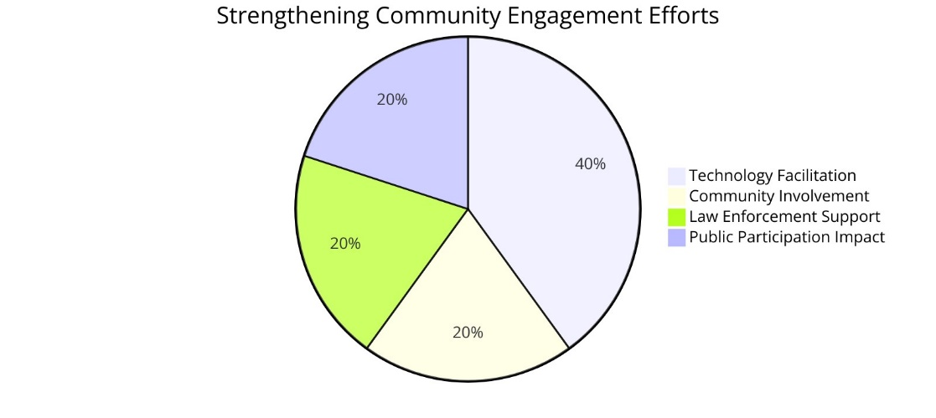

Fig 1.11.2: Strengthening Community Efforts

Top of Form

**CHAPTER 2**

**REVIEW OF LITERATURE**

**V. Shelke, G. Mehta, P. Gomase, and T. Bangera** have put forth a fresh idea to boost the effectiveness and precision of missing person identification systems by utilizing an improved face recognition algorithm. Their goal is to tackle the challenges in current methods of finding missing persons by using advanced facial recognition technologies. The main focus of their work is on enhancing the speed and accuracy of face recognition for practical situations through algorithm optimization. By combining complex machine learning models with a user-friendly interface, their system allows the public to actively join in the search for missing individuals. This inclusive approach expands search efforts and ensures that the technology is easy to use for real-life scenarios. The research highlights how advanced computational techniques can greatly improve existing systems in locating missing persons, highlighting technology's vital role in societal welfare tasks. Through thorough research and development, the team shows how optimized facial recognition algorithms can be used to create more efficient tools for public safety and law enforcement agencies.

**S. Alagarsamy, K. V. Sudheer Kumar, P. Vamsi, D. Bhargava, and B.D. Hemanth** presented a study on using deep learning to identify missing people at the 2021 5th International Conference on Computing Methodologies and Communication (ICCMC). They highlighted the use of an optimized facial recognition algorithm for better accuracy in locating missing persons and emphasized ethical data handling. In a similar study presented at the 2022 7th International Conference on Communication and Electronics Systems (ICCES), Alagarsamy et al. explored deep learning methods to identify missing individuals by utilizing deep neural networks to analyze complex datasets effectively under various conditions. Both studies emphasize the growing impact of AI and machine learning in public safety applications while focusing on ethical considerations and data privacy for future advancements in this field. The cumulative impact of their work, along with contributions from researchers like Iurii Medvedev, Farhad Shadmand, and Nuno Gonçalves, showcases a significant shift towards a more technologically empowered approach to child safety and public security. These advancements, grounded in ethical considerations and a commitment to privacy, pave the way for future innovations that not only harness the power of AI and facial recognition but do so in a manner that respects individual rights and fosters public trust.

Top of Form

**B. Sridhar, Sudeep Sharma, P. Srinivasa Rao, SVS Prasad, M. Raju Naik, and Vishal Vishwanath's** 2022 study on "Missing Children Identification using Face Recognition" presents a significant advancement in child safety and digital identification technology. By utilizing facial recognition algorithms, the team aims to create a system for identifying missing children more accurately and efficiently in diverse conditions. This research could greatly reduce the time taken to locate missing children, providing hope for affected families and improving the capabilities of law enforcement and child protection agencies. The study emphasizes integrating advanced technology with societal welfare goals to address complex human issues effectively. It also contributes to discussions on ethically using biometric data to balance privacy protection with leveraging technology for public benefit, laying the groundwork for future innovative solutions in child protection during the digital era.

**Iurii Medvedev, Farhad Shadmand, and Nuno Gonçalves** have made a significant advancement in facial recognition technology by introducing the "Young Labelled Faces in the Wild (YLFW)" dataset in 2023 on arxiv.org. This dataset focuses on improving the recognition of children's faces, addressing a gap in existing datasets that primarily concentrate on adult faces. Recognizing children's faces accurately is challenging due to their distinct physical characteristics and varying facial appearances over time. The YLFW dataset serves as a valuable resource for researchers and technologists to enhance facial recognition models specifically tailored for young faces. This advancement has broad applications, including improving child safety measures and developing content filtering systems suitable for different age groups. By concentrating on children's faces, Medvedev, Shadmand, and Gonçalves contribute to creating more inclusive and efficient facial recognition technologies that meet the diverse needs of global populations. Their work highlights the significance of specialized datasets in advancing AI and machine learning fields while ensuring that technological progress benefits all age groups equally. This contribution enriches discussions on facial recognition within academia and sets the stage for future innovations that can leverage this dataset to create safer digital environments inclusive of children. The work of Medvedev, Shadmand, and Gonçalves not only marks a significant advancement in facial recognition technology but also serves as a call to action for the research community to develop specialized datasets that cater to underrepresented groups.

**CHAPTER 3**

**PROPOSED SOLUTION**

**3.1 Overview of the Proposed Solution:**

Utilizing advanced AI technology, the solution aims to improve the identification of missing children through facial recognition algorithms. The system integrates MTCNN, FaceNet, and SVM to accurately identify missing children in images and videos from various sources.

**MTCNN** is the first step in facial recognition, detecting faces in images accurately. It is effective with different facial positions and expressions, making it valuable for extracting features from various sources.

**FaceNet** is the second part that focuses on extracting features to create unique facial embeddings for each detected face. These embeddings can be used to compare detected faces with those in a database of missing children accurately.

The classification phase uses a **Support Vector Machine (SVM)** to compare embeddings from FaceNet with a database. SVM categorizes these embeddings to determine if they match the faces of missing children in the system. This ensures accurate classification even in difficult situations.

The combination of three technologies creates a facial recognition system for missing children. It improves accuracy and speeds up matching found individuals with missing ones. Integrating AI aims to enhance collaboration between law enforcement, child protection agencies, and the public to locate missing children safely. The solution prioritizes ethics and privacy, especially in handling sensitive biometric data. It ensures compliance with strict data protection laws and ethical standards, strengthening its credibility as a socially responsible way to tackle the problem of missing children.

**3.2 Description of Technologies Used (MTCNN, Facenet, SVM):**

Integrating advanced facial recognition technologies like MTCNN, Facenet, and SVM into the proposed solution for missing children identification involves a series of computational steps, each contributing uniquely to the overall effectiveness of the system. Here, we delve into some of the formulas and expressions that underlie these technologies, illustrating how they work together to achieve high accuracy and efficiency.

**3.2.1 MTCNN (Multi-task Cascaded Convolutional Networks)**

MTCNN operates through a cascaded framework consisting of three stages, each designed for different aspects of face detection:

1. **Proposal Network (P-Net)** generates candidate window proposals**:**

* ***Pnet*​(*I*)={*Wp*​}, where *I* is the input image and *Wp*​ are the window proposals.**

1. **Refine Network (R-Net)** refines these windows, filtering out a subset of higher quality:

* ***Rnet*​(*Wp*​)={*Wr*​}, refining *Wp*​ to *Wr*​, a more accurate set of windows.**

1. **Output Network (O-Net)** further refines and outputs final bounding boxes and facial landmarks:

* ***Onet*​(*Wr*​)={*B*,*L*}, where *B* are the bounding boxes and *L* are the facial landmarks.**

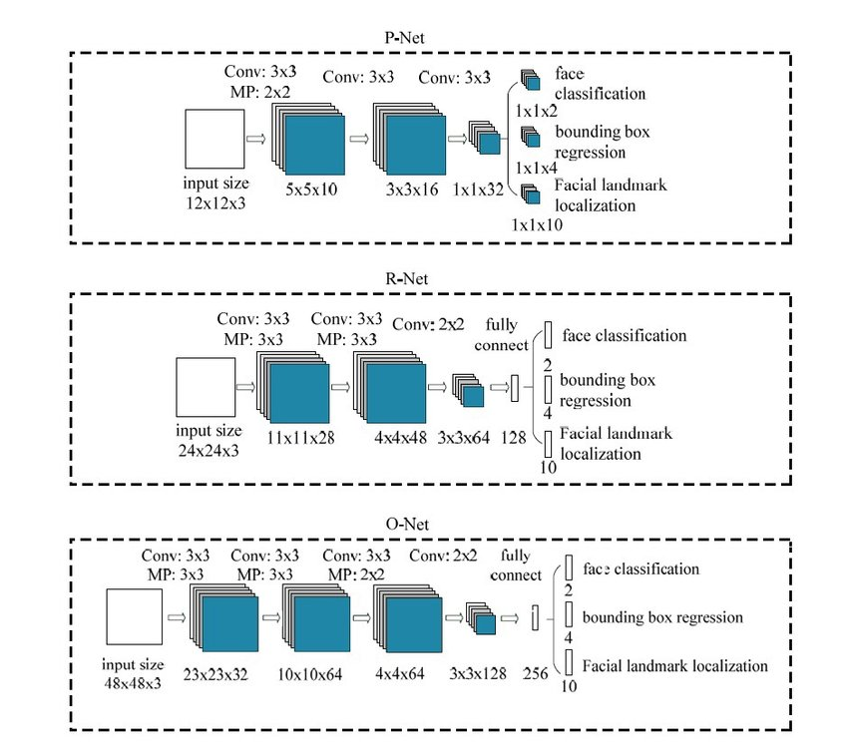

Fig 3.2.1: Multi-task Cascaded Convolutional Networks

This cascaded approach enables MTCNN to tackle the intricate task of face detection with remarkable precision, efficiently processing images to identify faces across a wide range of conditions

**3.2.2 FaceNet**

FaceNet uses a deep convolutional network to map face images into a compact Euclidean space. The distance between any two face embeddings in this space approximates the facial similarity:

Triplet Loss Function: Ensures that an anchor image *a* of a person is closer to all other positive images *p* (same person) than any negative image *n* (different person) by a margin *α*.

***L*=∑*I N*​max(0,∥*f*(*xa* (*i*) ​)−*f*(*xp*(*i*)​)∥2−∥*f*(*xa* (*i*)​ )−*f*(*xn*(*i*)​)∥2+*α*)**

Where *f*(*x*) denotes the embedding for an image *x*, and *N* is the number of triplets**.**

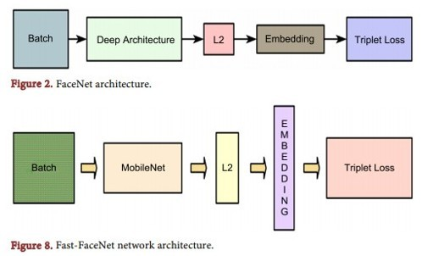

Fig 3.2.2: FaceNet Network Architecture

**3.2.3 SVM (Support Vector Machine)**

The final classification is performed using SVM, which operates by finding the hyperplane that best separates the embeddings of different classes in the feature space:

**Hyperplane Equation**: Given training vectors ***xi* ​∈ R*n***, i.e., facial embeddings in an n-dimensional space, and a label vector ***y* ∈ {1,−1}*l***, SVM solves the following optimization problem:

**Min *w*,*b*,*ξ*​ 1/2 ​*wTw* + *C*∑*i*=1*l*​ *ξi*​**

Subject to ***yi*​ (*wT ϕ*(*xi*​)+*b*) ≥1 − *ξi*​,** where ***ξi*​** are the slack variables allowing for margin violation, ***C*** is the penalty parameter, ***w*** is the normal vector to the hyperplane, ***b*** is the bias term, and ***ϕ*** represents the feature mapping function.

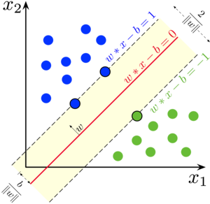

Fig 3.2.3: Support Vector Machine

The synergy between MTCNN, Facenet, and SVM, guided by these mathematical formulations, ensures the system's capability to deliver precise and reliable outcomes, thereby significantly contributing to child safety efforts.

**3.3 System Architecture and Workflow:**

The system architecture and workflow of the proposed solution for missing child identification harnesses the synergistic potential of MTCNN, Facenet, and SVM algorithms, creating a seamless and efficient process that optimizes the identification of missing children through advanced facial recognition technology. This architecture is designed to be scalable, robust, and user-friendly, ensuring that the system can handle large datasets with high accuracy and speed.

**System Architecture**

The architecture comprises several key components, each tailored to specific functionalities within the overall process:

1. **User Interface (UI):** A user-friendly mobile and web application that allows users to upload images of found children. This interface is designed for ease of use, ensuring widespread public participation. This approach democratizes the search process, leveraging collective vigilance and technology to create a safer environment for children worldwide.

2. **Image Processing Module:** Once an image is uploaded, it undergoes preprocessing, including resizing, normalization, and augmentation, to prepare it for effective facial recognition.

3. **MTCNN Module:** The first step in the facial recognition process, MTCNN, detects faces within the image and extracts facial features. It outputs candidate facial regions for further analysis.

4. **Facenet Module:** For each detected face, Facenet generates a unique facial embedding, a compact yet highly descriptive representation of the face's characteristics.

5. **Database:** A secure and encrypted database stores facial embeddings of missing children, alongside relevant metadata. This database is continually updated to ensure its comprehensiveness.

6. **SVM Classifier**: The SVM module compares the embedding generated from the uploaded image against those in the database, classifying the face as a potential match to a missing child based on similarity measures.

7. **Alert System**: Upon a positive match, the system triggers alerts to the relevant authorities and, if appropriate, to the user who uploaded the image, facilitating rapid response and verification.

8. **Analytics and Reporting**: An analytics module provides insights into system performance, user engagement, and identification success rates, aiding continuous improvement.

**Workflow**

The workflow illustrates the step-by-step process from image upload to potential match identification:

1. **Image Upload**: A user uploads an image of a found child via the UI.

2. **Preprocessing:** The image processing module preprocesses the image for optimal facial recognition.

3. **Face Detection**: MTCNN detects faces within the image, delineating candidate regions for further analysis.

4. **Feature Extraction**: For each detected face, Facenet generates a facial embedding, encapsulating the unique features of the face.

5. **Matching:** The SVM classifier compares the generated embedding against the database of missing children's embeddings to identify potential matches based on predefined similarity thresholds.

6. **Alert Generation:** Upon identifying a potential match, the system triggers an alert to authorities and provides feedback to the user.

7. **Verification and Follow-up:** Law enforcement or child protection agencies undertake verification processes and necessary follow-up actions.

8. **Analytics and Improvement**: System performance and user interaction data are analyzed to identify opportunities for system enhancement.

As the system evolves and adapts to new challenges and opportunities, it continues to underscore the importance of ethical considerations, community involvement, and international collaboration in leveraging technology for the greater good, ensuring that the benefits of these advancements are shared broadly and equitably across societies.

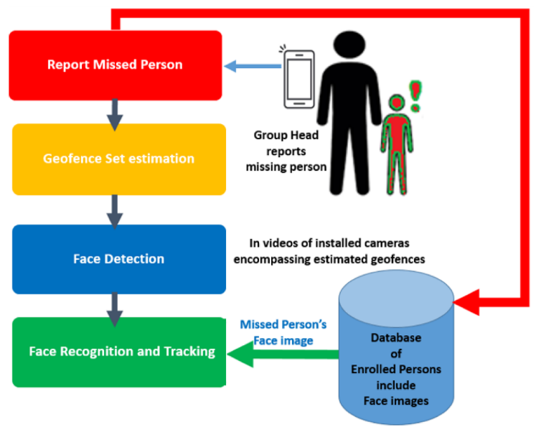

Fig 3.3: Workflow of Missing Child Tracker

This architecture and workflow demonstrate the comprehensive approach of the proposed solution, leveraging advanced technologies to streamline the process of locating missing children, ensuring swift, accurate identification and response.

**3.4 Data Collection and Privacy Measures:**

The proposed system for locating missing children through advanced facial recognition technology places a significant emphasis on data collection and the implementation of rigorous privacy measures. These aspects are crucial for ensuring the system's effectiveness while upholding the highest standards of data protection and ethical considerations.

**Data Collection**

Data collection in the system is multifaceted, encompassing the gathering of facial images, metadata, and user-generated content:

**1.** **Facial Images**: The primary data consists of facial images of missing children, obtained from public records, law enforcement databases, and directly from guardians or family members. Each submission is accompanied by consent forms and relevant documentation to ensure lawful and ethical data acquisition.

**2. Metadata**: Alongside images, metadata such as the date of disappearance, last known location, and any distinguishing features are collected to aid in the identification process and provide contextual information for each case.

**3. User-Generated Content**: The system also allows the public to upload images of found children. These submissions are accompanied by location data and timestamps, providing valuable leads for investigations.

**Privacy Measures**

Given the sensitivity of the data involved, the system incorporates several privacy measures to protect individual rights and comply with data protection laws:

**1. Encryption**: All data transmitted to and stored within the system is encrypted using advanced encryption standards. This ensures that facial images and personal information are protected against unauthorized access.

**2. Anonymization**: Where possible, data is anonymized to remove or obscure personal identifiers. This minimizes the risk of personal data exposure and ensures that the system can be used without compromising individual privacy.

**3. Access Control**: Access to the data is strictly controlled, with multiple layers of authentication required for system administrators and authorized personnel. User roles and permissions are clearly defined, limiting access to sensitive data based on necessity.

**4. Data Minimization**: The principle of data minimization is adhered to, ensuring that only the necessary data for the identification process is collected and retained. This reduces the potential for privacy breaches and complies with regulatory requirements.

**5. Consent and Transparency**: The system operates on the basis of informed consent, with clear explanations provided to guardians, family members, and the public regarding how their data will be used. Users have the right to withdraw their consent at any time, with procedures in place for the deletion of their data.

**6. Regular Audits and Compliance Checks**: To ensure ongoing compliance with privacy laws and ethical standards, the system undergoes regular audits and compliance checks. These reviews help identify and rectify any potential privacy issues or vulnerabilities. By proactively identifying and addressing any potential privacy issues or vulnerabilities, the system can prevent data breaches and unauthorized access, safeguarding the information of both the users and the children it aims to protect. This commitment to ongoing compliance not only reinforces the system's reliability but also strengthens public confidence in its use as a tool for societal benefit.

Top of Form

By prioritizing data collection and privacy measures, the proposed system demonstrates a commitment to ethical practices and legal compliance. These efforts not only enhance the system's trustworthiness and user acceptance but also underscore the importance of balancing technological advancements with the safeguarding of individual rights in the pursuit of societal benefits.

**3.5 Integration with Existing Child Safety Networks**

The facial recognition system will be integrated with child safety networks to enhance effectiveness and broaden impact. This integration creates a comprehensive ecosystem leveraging strengths of organizations and technologies for child protection, enabling seamless communication and collaborative efforts.

**Establishing Interoperability**

Interoperability is crucial for the integration process, ensuring that the proposed system can communicate and exchange data with different child safety networks and databases seamlessly. This involves adopting common data standards and protocols, enabling the system to interface with national and international child protection databases, law enforcement agencies, non-governmental organizations (NGOs), and other relevant entities. It supports the development of a global response network, capable of mobilizing resources and expertise from around the world to address child disappearances.

**Data Sharing Agreements**

To facilitate the secure and ethical exchange of information, data sharing agreements are established with all participating organizations. These agreements outline the terms of data usage, privacy protections, responsibilities, and obligations of each party, ensuring that all data exchanges are compliant with relevant privacy laws and regulations.

**Real-time Data Access and Updates**

The system provides real-time access to updated information on missing children cases, making it a dynamic tool for child safety efforts. By integrating with existing networks, the system can instantly receive and disseminate alerts, updates, and recovered child reports, ensuring that all stakeholders have access to the most current information.

**Collaborative Search and Identification Efforts**

The integration fosters a collaborative approach to searching for and identifying missing children. By pooling resources, expertise, and information from various child safety networks, the system enhances the collective ability to locate and recover missing children more efficiently and effectively.

**Training and Support**

To maximize the benefits of integration, training sessions and support resources are provided to all participating organizations. This ensures that staff and volunteers are well-equipped to use the system, understand its capabilities, and contribute to its success. Training focuses on operational procedures, privacy considerations, and best practices for data handling and child safety.

**Feedback Loop for Continuous Improvement**

An essential component of the integration is the establishment of a feedback loop, allowing participating organizations to provide insights, report issues, and suggest improvements. This collaborative feedback mechanism ensures that the system continually evolves to meet the changing needs of child safety efforts, incorporating new technologies, methodologies, and insights gained from real-world operations.

The facial recognition system joins child safety networks to enhance efforts against disappearances. This collaboration amplifies effectiveness and shows a shared commitment to using technology for the greater good, giving every child a better chance of being found and kept safe.

**3.6 Dataset Description and Preparation**

The AI-Powered Missing Child Locator App, as outlined in the provided document, utilizes the Young Labelled Faces in the Wild (YLFW) dataset, a critical resource in the development and enhancement of its facial recognition capabilities tailored for children. This dataset, along with a combination of cutting-edge algorithms MTCNN, FaceNet, and SVM forms the backbone of the project's approach to locating missing children with high accuracy and efficiency**.**

**YLFW Dataset Usage**

The YLFW dataset, a specialized collection of facial images focusing on young individuals, plays a pivotal role in training the facial recognition models employed by the app. This dataset includes more than 1,500 images across 60 identities, covering a wide age range from 1 to 30 years. The diversity and comprehensiveness of YLFW are instrumental in addressing the unique challenges posed by facial recognition in children, who may exhibit rapid physical changes that complicate identification efforts.

**Dataset Preparation**

The preparation of the YLFW dataset for use in this project involved several steps designed to optimize the dataset for facial recognition processing:

**1. Preprocessing:** Initial preprocessing included resizing images for uniformity, adjusting lighting conditions, and normalizing facial orientations to ensure that the dataset is conducive to accurate recognition across varying real-world conditions**.**

**2. Data Augmentation:** To further enhance the model's robustness and its ability to generalize across different facial expressions, angles, and environmental conditions, data augmentation techniques such as flipping, rotation, and scaling were applied to the images in the YLFW dataset.

**3. Feature Extraction and Training:** Utilizing the FaceNet algorithm, deep learning models were trained on the preprocessed and augmented dataset to generate facial embeddings. These embeddings capture the unique features of each face in a high-dimensional space, facilitating accurate comparison and identification.

**Integration of MTCNN, FaceNet, and SVM**

The backbone of the project's approach to locating missing children with high accuracy and efficiency. The project employs a systematic approach to facial recognition, leveraging the strengths of multiple algorithms**:**

* **MTCNN** is utilized for its efficiency in detecting faces within images, providing the critical first step in identifying potential matches within the dataset**.**

* **Facenet** takes over to extract high-quality facial embeddings from the detected faces. By mapping these images into a compact Euclidean space, Facenet allows for the precise comparison of facial features.
* **SVM** is then used to classify the facial embeddings against the database of missing children's embeddings. This final step determines the likelihood of a match, leveraging the distinct characteristics captured in the embeddings.

**YLFW Dataset Benchmarking**

The document also highlights the importance of benchmarking the facial recognition model against the YLFW dataset. By dividing the dataset into training and testing sets and employing a 10-fold cross-validation method, the project team was able to rigorously evaluate the model's performance. This approach ensures that the system is capable of consistently identifying young faces with a high degree of accuracy, reflecting its potential effectiveness in real-world applications for locating missing children.

**CHAPTER 4**

**IMPLEMENTATION**

**4.1 Facial Recognition Technologies:**

The section on Facial Recognition Technologies can be elaborated as follows, considering the integration and application of MTCNN, FaceNet, and SVM within the project:

**4.1.1 Implementation of MTCNN**

The Multi-task Cascaded Convolutional Networks (MTCNN) serve as the initial step in our facial recognition pipeline, tasked with the accurate detection of faces within images uploaded to the app. MTCNN operates through a cascaded framework consisting of three stages P-Net, R-Net, and O-Net that progressively refine the detection process. Each stage applies convolutional networks to predict face and non-face regions, bounding box regression, and facial landmarks, ensuring precise localization of facial features even in challenging conditions such as varying lighting and orientations. This method's effectiveness lies in its ability to handle diverse facial expressions and backgrounds, making it a crucial component of our system for identifying missing children.

**4.1.2 FaceNet Integration**

Following the detection of faces by MTCNN, Facenet is employed to extract facial embeddings a high-dimensional representation of facial features. Facenet's deep convolutional network is trained to minimize the distance between embeddings of the same face while maximizing the distance between embeddings of different faces, using a triplet loss function. This process results in embeddings that accurately capture the unique characteristics of each face. These embeddings are critical for the subsequent classification step, as they provide a reliable basis for comparing the uploaded images against the database of missing children with high precision. The integration of Facenet into our project enhances the system's ability to discern subtle differences between faces, significantly improving match accuracy.

**4.1.3 SVM Classification**

The final step in our facial recognition process involves the Support Vector Machine (SVM) algorithm, which classifies the extracted facial embeddings to identify potential matches within the missing children database. SVM works by finding the hyperplane that best separates the embeddings into two classes matches and non-matches with a maximized margin. In our project, SVM is finely tuned to handle the high-dimensional data produced by FaceNet, ensuring robust and accurate classification. This classification step is pivotal, as it determines the likelihood of an uploaded image matching a profile in the missing child database. Through careful calibration and continuous optimization, SVM provides a powerful mechanism for distinguishing between potential matches, thereby playing an integral role in the locator system's overall effectiveness.

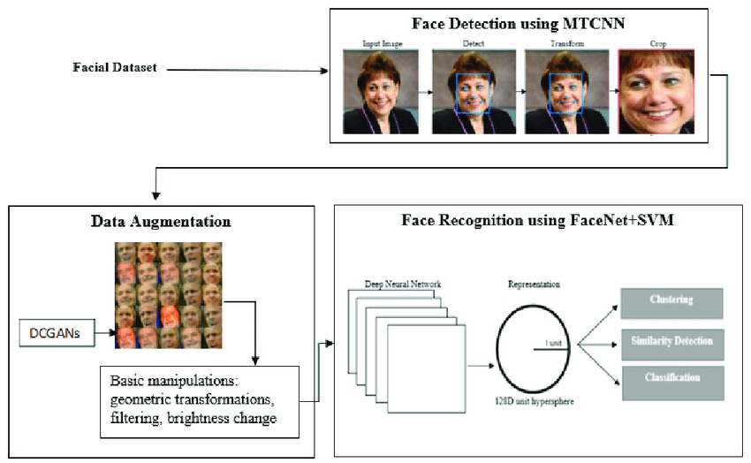

Fig 4.1.3: Facial Recognition Technologies

The seamless integration and nuanced application of these facial recognition technologies MTCNN for detection, FaceNet for feature extraction, and SVM for classification form the cornerstone of the AI-Powered Missing Child Locator project. This sophisticated approach not only leverages the strengths of each technology but also addresses the challenges inherent in accurately identifying missing children, showcasing the project's innovative use of AI to serve a vital social cause.

### **4.2 Dataset Preparation and Benchmarking:**

The section of the AI-Powered Missing Child Locator project documentation delves into the specifics of how the Young Labelled Faces in the Wild (YLFW) dataset is utilized, prepared, and benchmarked to enhance the project's facial recognition capabilities.

**4.2.1 YLFW Dataset Usage**

The YLFW dataset, essential for training the facial recognition system, includes a diverse collection of children's facial images, catering to a wide age range from 1 to 30 years. This dataset's diversity is pivotal for developing a facial recognition model capable of accurately identifying missing children across various demographics.

**4.2.2 Preprocessing and Data Augmentation**

Preparation of the YLFW dataset for effective application involves several critical steps:

**Data Cleaning**: Initial cleaning processes remove duplicates and low-quality images, ensuring that only relevant and clear images are included in the training set.

**Data Augmentation**: To bolster the robustness of the facial recognition model and its ability to generalize across different conditions, data augmentation techniques such as flipping, rotation, and scaling are applied. These techniques help simulate various real-world scenarios, including different facial expressions, orientations, and lighting conditions.

**Normalization**: All images are normalized to a standard size and format, facilitating uniform processing. This normalization is crucial for reducing computational complexity and ensuring consistent input quality for the facial recognition algorithms.

**4.2.3 Benchmarking on YLFW**

Benchmarking the facial recognition system's performance against the YLFW dataset involves a meticulous process:

**10-Fold Cross-Validation**: The dataset is divided into ten folds, with the system trained on nine folds and tested on the remaining one. This process is repeated ten times to ensure each fold serves as the test set once, allowing for a comprehensive evaluation of the model's performance.

**Performance Metrics**: The system's accuracy, precision, recall, and F1 score are measured and reported. These metrics provide a nuanced understanding of the system's efficacy in identifying missing children based on facial recognition.

**Comparison with State-of-the-Art Models**: The system's performance is compared to existing facial recognition models that have been benchmarked on the YLFW dataset. This comparison highlights the project's relative effectiveness and areas for potential improvement.

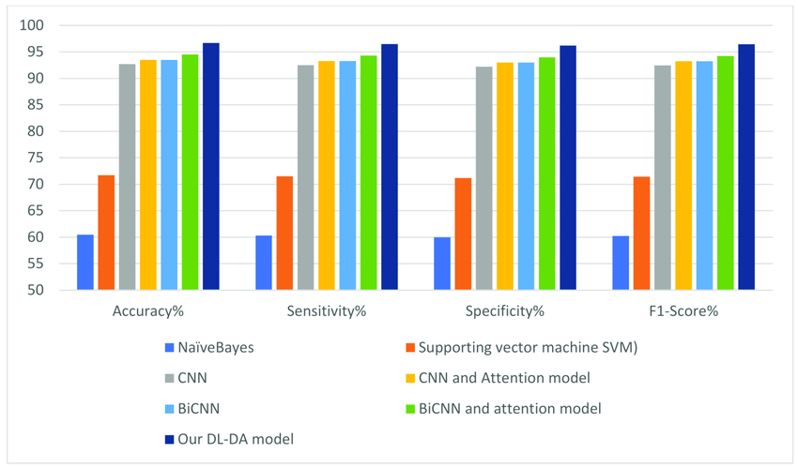

Fig 4.2.3: Comparison with State-of-the-Art Models

This benchmarking process not only validates the effectiveness of the AI-Powered Missing Child Locator's facial recognition system but also underscores its potential for real-world application in locating missing children. The detailed preparation and rigorous evaluation of the YLFW dataset serve as a testament to the project's commitment to leveraging advanced technology for societal benefit.

**4.3 Development Tools and Environment:**

**4.3.1 Android Studio**

Introduction to Android Studio is the chosen development platform for the implementation of the AI-Powered Missing Child Locator project's mobile application.

**4.3.2 Programming Languages**

* **4.3.2.1 Java**: Use of Java in app development.
* **4.3.2.2 Kotlin**: Use of Kotlin for modern Android app development.

**4.3.3 Front-End Development**

* **4.3.3.1 XML**: Utilization of XML for layout designs.
* **4.3.3.2 Android XML Layouts**: Application of Android-specific XML layouts for UI design.

**4.3.4 Database Management**

* **4.3.4.1 Firebase Realtime Database**: Integration for real-time data handling.
* **4.3.4.2 Firestore**: Use of Firestore for efficient data storage and synchronization.

**4.3.5 Version Control**

* **4.3.5.1 Git**: Implementation of Git for code versioning and team collaboration.

**4.3.6 Integrated Development Environment (IDE)**

Detailed on Android Studio’s role as the IDE for the project.

**4.3.7 Graphics and Image Editing**

* **4.3.7.1 Adobe Photoshop**: Role in creating visual assets.
* **4.3.7.2 Adobe Illustrator**: Contribution to graphic design elements.

**4.3.8 API Development Tools**

* **4.3.8.1 Postman**: Usage for backend API development and testing.

**4.3.9 Google Maps Plugin API**

Integration and application of Google Maps SDK for location services.

**4.3.10 User Interface Design Tools**

* **4.3.10.1 Figma**: Adoption for UI/UX design and prototyping.
* **4.3.10.2 Sketch**: Application for interface design.

**4.3.11 Testing Framework**

* **4.3.11.1 Espresso**: Utilization for automated UI testing.

**4.3.12 Emulation and Testing**

* **4.3.12.1 Android Emulator**: Employment for app testing across different devices.

**Hardware Requirements**

A breakdown of the required hardware specifications to support the application's optimal performance and user experience, including details on operating systems, processors, memory, storage, display, camera, internet connectivity, and GPS/location services.

**4.4 Security and Privacy Measures:**

**4.4.1 Encryption Protocols**

* **Data Transmission Security**: Implement SSL/TLS encryption to secure data transmitted between the mobile app and servers, ensuring that user uploads, authentication data, and any communication are protected against interception.
* **Database Encryption**: Apply encryption techniques to sensitive data stored in the database, such as user personal information and facial images, to protect against unauthorized access and data breaches.

**4.4.2 Authentication and Access Control**

* **Robust User Authentication**: Utilize multi-factor authentication (MFA) for user login processes to add an extra layer of security beyond just usernames and passwords. This might include SMS codes, email verification links, or biometric verification.

**4.4.3 Compliance with Data Protection Regulations**

* **GDPR and Other Privacy Laws**: Ensure that all aspects of the app, from data collection to processing and storage, comply with the General Data Protection Regulation (GDPR) for EU citizens, and other relevant data protection laws, reflecting a commitment to user privacy.
* **User Consent and Transparency**: Incorporate clear consent forms and privacy policy agreements within the app registration process, informing users about how their data will be used and stored, and providing them with control over their personal information.

**4.4.4 Anonymization and Data Minimization**

* **Anonymization of Sensitive Data**: Wherever possible, anonymize user data and facial recognition data to prevent the identification of individuals from the stored data, especially in the context of shared databases.
* **Principle of Data Minimization**: Adhere to the principle of collecting only the data necessary for the intended purpose of locating missing children, avoiding excessive data collection that could infringe on user privacy.

**4.4.5 Regular Security Audits and Updates**

* **Security Auditing**: Conduct regular security audits to identify and address vulnerabilities within the app and server infrastructure, including penetration testing and code reviews.
* **Software and Security Updates**: Keep the app and its underlying systems up to date with the latest security patches and updates, mitigating risks associated with software vulnerabilities.

**4.4.6 User Data Control and Portability**

* **Right to Data Access and Deletion**: Enable users to request access to their data stored by the app and provide an easy mechanism for them to request data deletion, in line with data protection rights and regulations.

**4.4.7 Incident Response Plan**

* **Rapid Response to Data Breaches**: In the AI-Powered Missing Child Locator project, the security and privacy of user data are paramount. To ensure rapid response to any potential data breaches or security incidents, the project implements and maintains a comprehensive incident response plan. This plan outlines the steps to be taken in the event of a data breach, including mechanisms for notifying affected users and mitigating damages effectively.

**4.5 User Interface and Experience**

The AI-Powered Missing Child Locator app is designed with a focus on providing an intuitive and seamless user experience, enabling users to navigate the app efficiently and perform tasks without unnecessary complexity.

* + 1. **Intuitive Design**
* **User-Centric Design Principles:** The app's design follows user-centric principles, ensuring that the interface is intuitive and accessible to users of all technical backgrounds.
* **Consistent Layout and Navigation:** A consistent layout and navigation scheme across the app facilitate ease of use, allowing users to intuitively understand how to access various features.

**4.5.2 Accessibility Features**

* **Compliance with WCAG:** The app adheres to the Web Content Accessibility Guidelines (WCAG), ensuring it is accessible to users with disabilities, including those who require screen readers or other assistive technologies.
* **Customizable Interface Options:** Features such as adjustable text sizes and contrast settings enable users to tailor the app's interface to their preferences, enhancing accessibility.

**4.5.3 Real-Time Feedback and Notifications**

* **Instant Feedback:** Users receive immediate feedback on their actions within the app, such as successful report submissions or recognition processes, fostering a responsive user experience.
* **Notification System:** A robust notification system informs users about significant events, such as potential matches or updates on cases they've reported, keeping them engaged and informed.

**4.5.4 Interactive Tutorials and Support**

* **Onboarding Tutorials:** Interactive tutorials guide new users through the app's features and functionalities, ensuring they can fully leverage the app's capabilities from the start.
* **In-App Support and FAQ:** An in-app support system and a comprehensive FAQ section address common user queries and issues, providing assistance directly within the app environment.

By integrating these security, privacy, and user experience measures, the AI-Powered Missing Child Locator app aims to deliver a secure, user-friendly, and effective tool for contributing to child safety efforts.

**4.6 Monitoring and Updates:**

The AI-Powered Missing Child Locator project places significant emphasis on maintaining high performance, reliability, and user satisfaction through diligent monitoring and regular updates.

**4.6.1 Performance Monitoring and Analytics**

* **Real-time System Monitoring**: Utilizes tools to continuously monitor the app's performance, identifying any bottlenecks or issues that could affect user experience.
* **User Engagement Analytics**: Tracks key metrics such as active users, session lengths, and feature usage to understand how users interact with the app and identify areas for improvement.
* **Error Reporting and Resolution**: Implements an automated error reporting system to capture and analyze exceptions or bugs encountered by users, facilitating quick resolution and minimizing impact.

**4.6.2 User Feedback and Community Engagement**

* **Feedback Collection Mechanisms**: In the AI-Powered Missing Child Locator project, the mobile application incorporates robust mechanisms for collecting feedback from users, ensuring continuous improvement and enhancing user experience
* **Community Engagement**: Engages with users through social media, newsletters, and other channels to keep them informed about the project, gather community input, and foster a sense of ownership and involvement.

**4.6.3 Continuous Improvement and Feature Updates**

* **Agile Development Cycle**: Adopts an agile approach to development, enabling the team to rapidly iterate on the app based on user feedback, analytics, and changing requirements.
* **Feature Rollouts and Updates**: Regularly releases updates that include new features, improvements to existing functionalities, and optimizations to enhance the app's performance and user experience.

**4.6.4 Security Updates**

* **Security Patch Management**: In the AI-Powered Missing Child Locator project, ensuring the security of the mobile application and its underlying infrastructure is a top priority. To mitigate the risk of potential security vulnerabilities, the project implements a robust security patch management process.

**4.6.5 Disaster Recovery and Data Backup**

**Disaster Recovery**

* **Regular Backups:** The project implements regular backups of user data and system configurations to prevent data loss in the event of a disaster. Backups are scheduled at regular intervals to capture the most recent changes and updates to the data.
* **Redundant Storage:** Backup data is stored in redundant storage systems to ensure redundancy and fault tolerance. This may include off-site backups in geographically diverse locations to mitigate the risk of data loss due to regional disasters.**Top of Form**
  1. **System Design**

**INPUT DESIGN**

The input design is the link between the information system and the user. It comprises the developing specification and procedures for data preparation and those steps are necessary to put transaction data in to a usable form for processing can be achieved by inspecting the computer to read data from a written or printed document or it can occur by having people keying the data directly into the system. The design of input focuses on controlling the amount of input required, controlling the errors, avoiding delay, avoiding extra steps and keeping the process simple. The input is designed in such a way so that it provides security and ease of use with retaining the privacy.

**OUTPUT DESIGN**

A quality output is one, which meets the requirements of the end user and presents the information clearly. In any system results of processing are communicated to the users and to other system through outputs. In output design it is determined how the information is to be displaced for immediate need and also the hard copy output. It is the most important and direct source information to the user

**UML Diagram**

UML stands for Unified Modelling Language. UML is a standardized general-purpose modelling language in the field of object-oriented software engineering. The standard is managed, and was created by, the Object Management Group. The goal is for UML to become a common language for creating models of object-oriented computer software. In its current form UML is comprised of two major components: A Meta-model and a notation. In the future, some form of method or process may also be added to or associated with, UML.

The Unified modelling Language is a standard language for specifying, Visualization, Constructing and documenting the artifacts of software system, as well as for business modelling and other non-software systems. The UML represents a collection of best engineering practices that have proven successful in the modelling of large and complex systems.

The UML is a very important part of developing objects-oriented software and the software development process. The UML uses mostly graphical notations to express the design of software projects.

**USE CASE DIAGRAM:**

A use case diagram in the Unified Modeling Language (UML) is a type of behavioral diagram defined by and created from a Use-case analysis. Its purpose is to present a graphical overview of the functionality provided by a system in terms of actors, their goals (represented as use cases), and any dependencies between those use cases. The main purpose of a use case diagram is to show what system functions are performed for which actor. Roles of the actors in the system can be depicted.

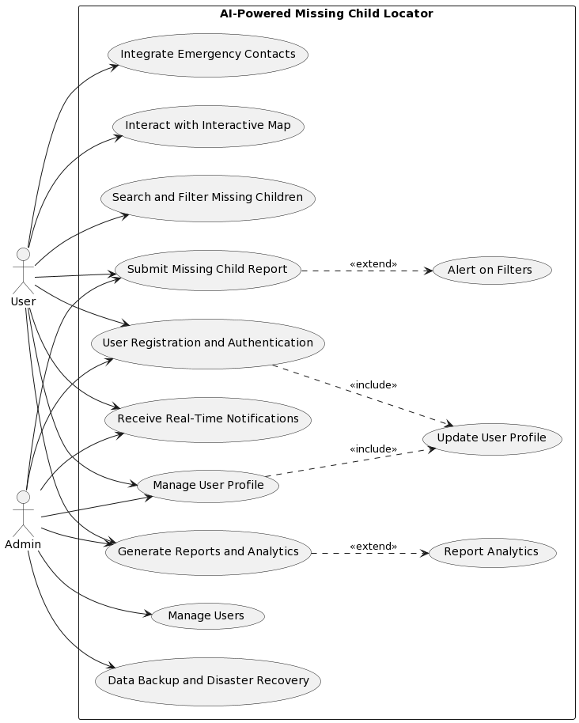

Fig 4.7.1: Use Case Diagram

Use case diagrams are a fundamental part of UML, offering a straightforward and effective way to capture the functional requirements of a system. They facilitate early detection of requirements misunderstandings, serve as a guide for further system development activities, and help ensure that the final system aligns with user needs and expectations.**Top of Form**

**CLASS DIAGRAM:**

In software engineering, a class diagram in the Unified Modelling Language (UML) is a type of static structure diagram that describes the structure of a system by showing the system's classes, their attributes, operations (or methods), and the relationships among the classes. It explains which class contains information.

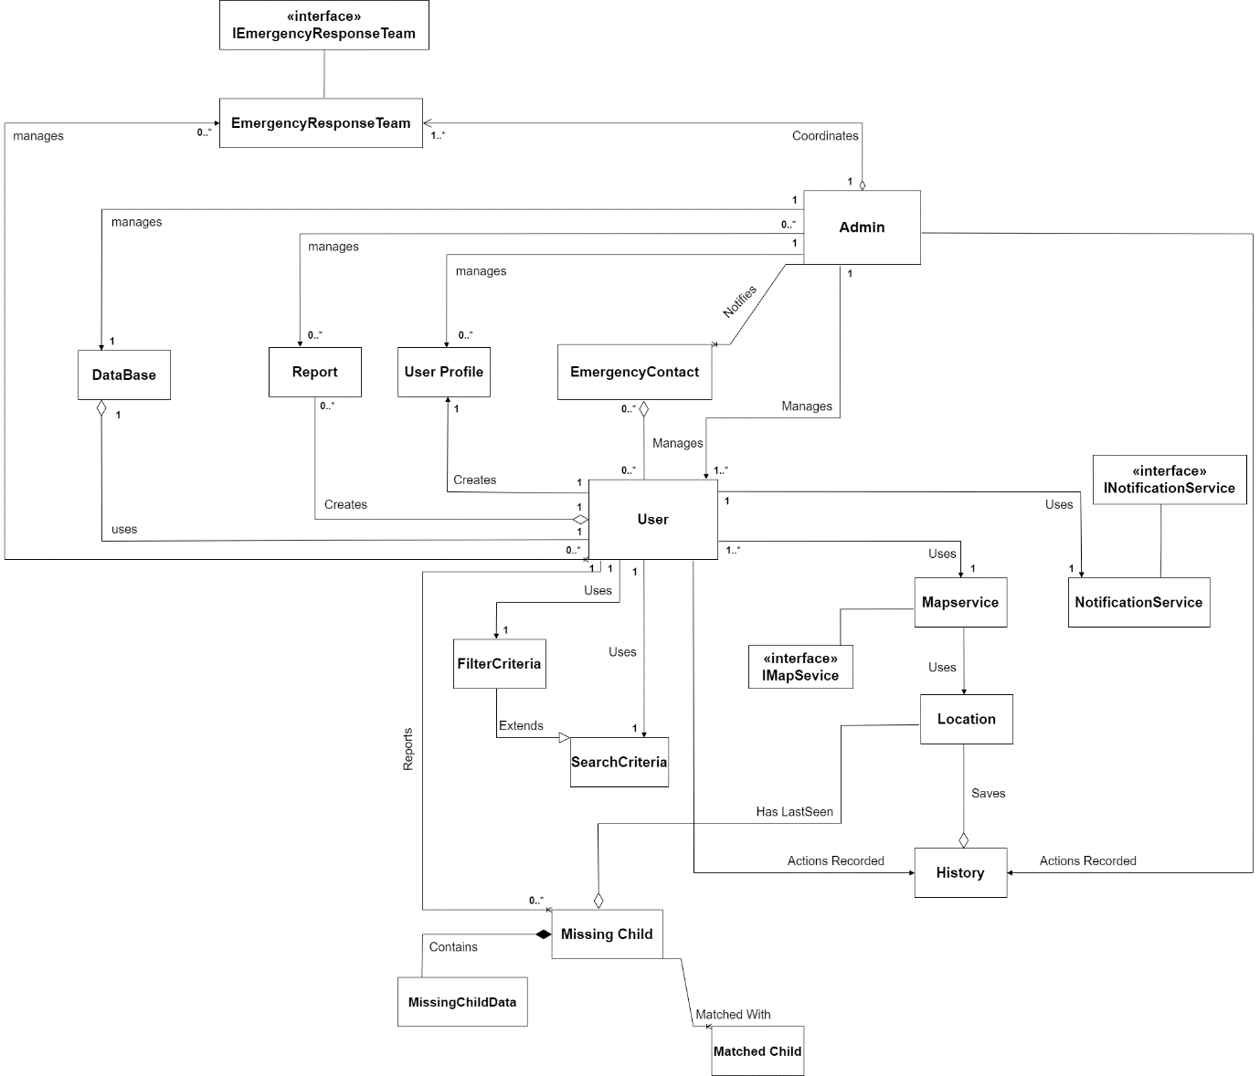

Fig 4.7.2: Class Diagram

This extensive representation is vital for understanding the system's potential capabilities and for identifying how different parts of the system interact with each other. As such, class diagrams are indispensable tools for both the design and implementation phases of software development, offering a blueprint that guides developers in constructing a system that aligns with the intended architecture and design patterns. Through the use of class diagrams, the structural foundation of a software application becomes transparent, facilitating a more straightforward development process and enabling teams to maintain a high level of consistency and quality in their software products.

**SEQUENCE DIAGRAM:**

A sequence diagram is a type of interaction diagram that visualizes how objects in a system interact with each other over time. It illustrates the flow of messages and interactions between different components or objects within a system. Sequence diagrams are commonly used in software engineering to represent the dynamic behaviour of a system, especially during the design and analysis phases of software development.

It is a construct of a Message Sequence Chart. Sequence diagrams are sometimes called event diagrams, event scenarios, and timing diagrams.

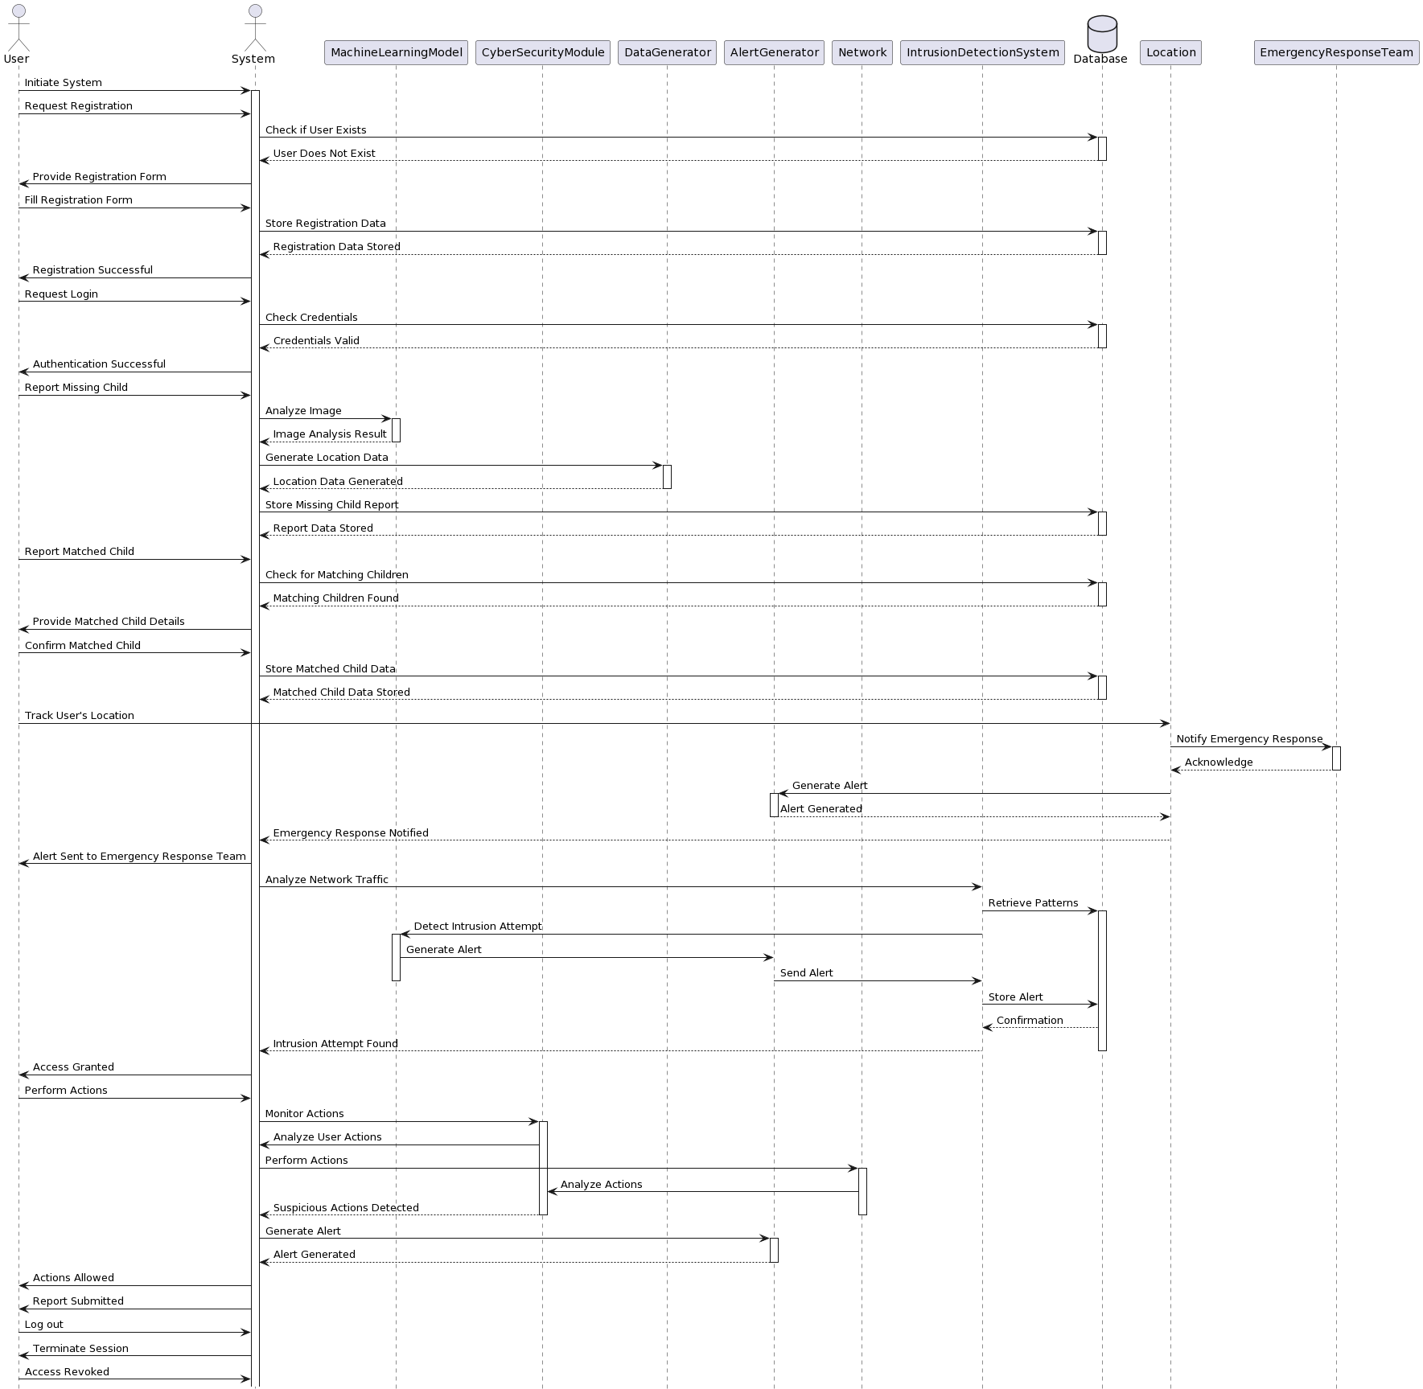

Fig 4.7.3: Sequence Diagram

By visualizing complex scenarios, sequence diagrams aid in the verification of system architecture and functionality, ensuring that the final product aligns with the desired outcome.

**ACTIVITY DIAGRAM:**

Activity diagrams are graphical representations of workflows of stepwise activities and actions with support for choice, iteration and concurrency. In the Unified Modelling Language, activity diagrams can be used to describe the business and operational step-by-step workflows of components in a system. An activity diagram shows the overall flow of control.

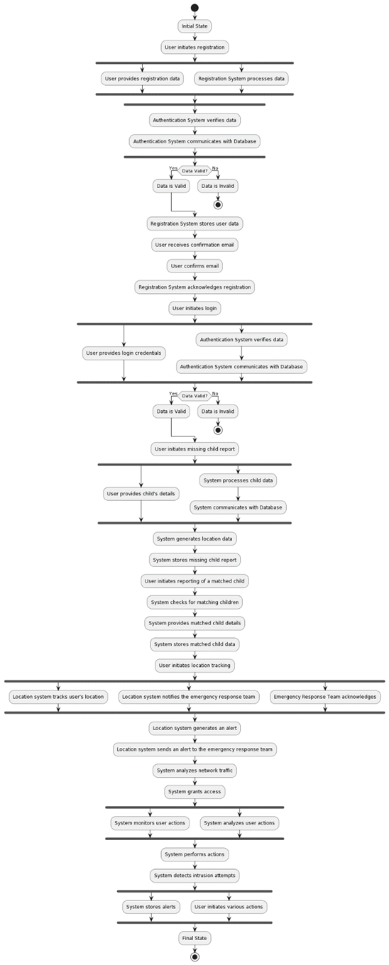

Fig 4.7.4: Activity Diagram

**COMPONENT DIAGRAM:**

A component diagram is a type of structural diagram in Unified Modelling Language (UML) that depicts the components of a system and the relationships between them. It provides a high-level view of the architecture of a software system, showing how the different parts of the system are organized and interact with each other.

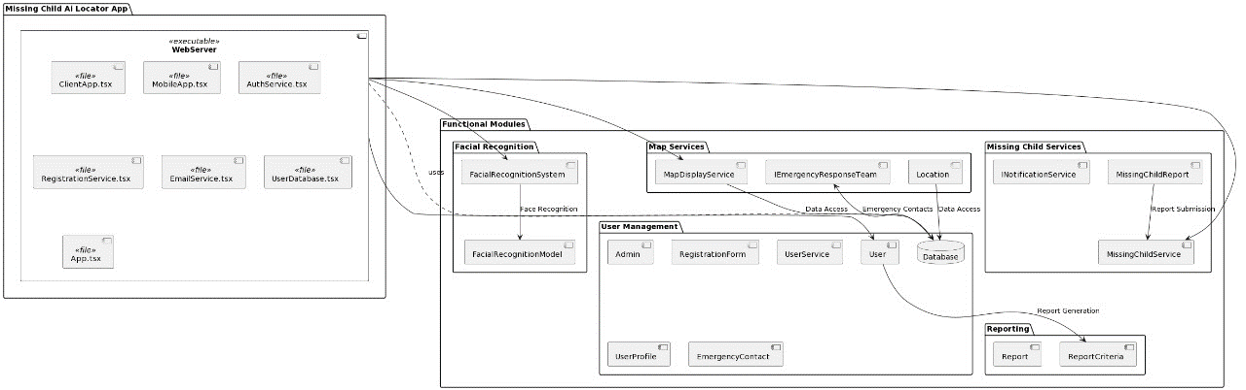

Fig 4.7.5: Component Diagram

**DEPLOYMENT DIAGRAM:**

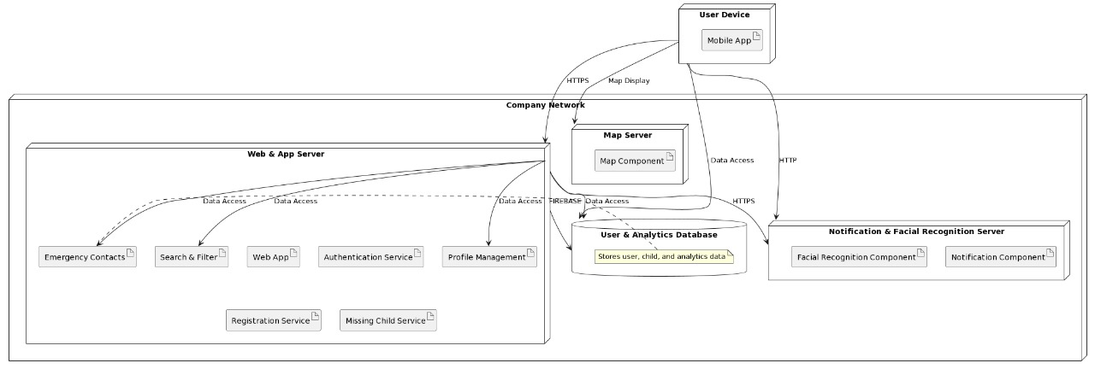Fig 4.7.6: Deployment Diagram

A deployment diagram in Unified Modeling Language (UML) is a diagram that depicts the physical deployment of artifacts on nodes. It shows how software components and artifacts are deployed across hardware nodes, typically in a networked environment. Deployment diagrams are used to visualize the topology of a system, including hardware and software components, and how they are interconnected.

**STATE CHART DIAGRAM:**

A state chart diagram, also known as a state machine diagram, is a type of diagram in the Unified Modeling Language (UML) that represents the behavior of a system or an object over time. It visually depicts the different states that an object or system can be in, as well as the transitions between those states in response to events or conditions.

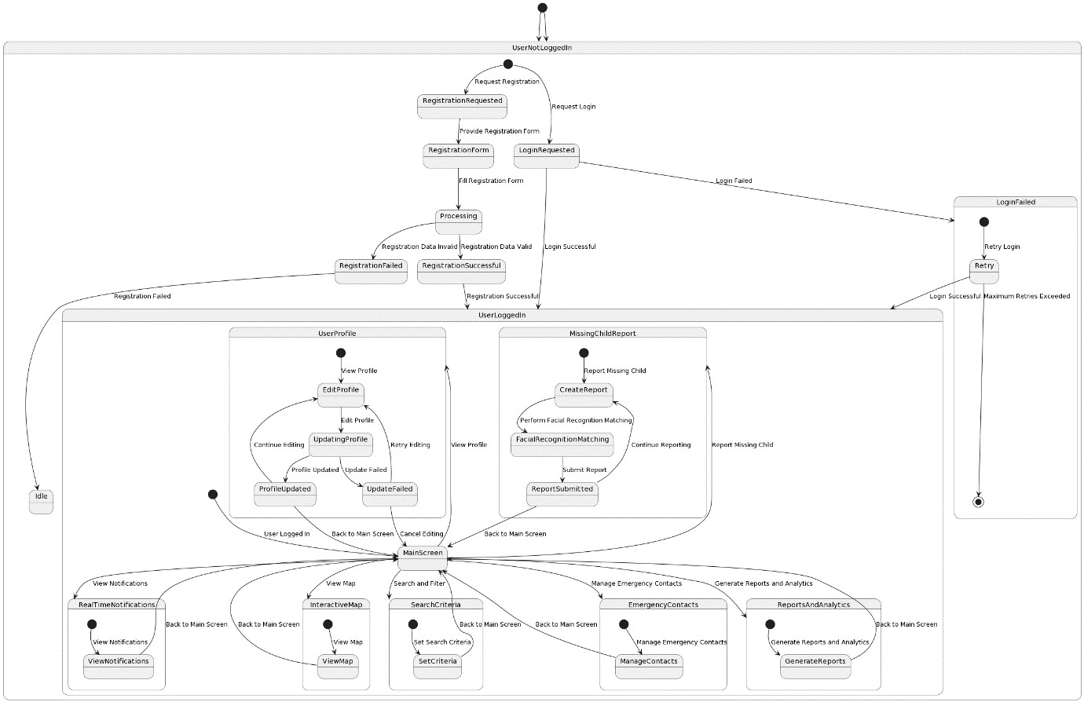Fig 4.7.7: State Chart Diagram

* 1. **Android app integration**

At the top, there's a personalized greeting to the user, "Hi, Name," indicating a user-profile feature in the app. It also shows the user's location as Location name - pincode, AP, India, which suggests the app has geolocation capabilities.

Below the greeting, there are three statistics prominently displayed:

* **Total missing Children**: The number '10' indicates the total number of missing children reported through the app.
* **Found Children**: The number '4' reflects the children that have been located or recovered.
* **Children Still Missing**: The number '6' represents the children who are currently still missing.

**Emergency Contacts**: There's a prompt for the user to add their emergency contacts, which can be a critical feature for immediate communication in urgent situations.

**Reporting & Analytics Section**: This section appears to provide detailed analytics on missing children's reports.

* **Line Graph (Total Children):** The line graph seems to show the trend of total children reported over different years. It may indicate fluctuations in the number of reports.
* **Bar Chart (Year wise Statistics):** A bar chart shows year-specific data for a selected year (in this case, 2020), possibly detailing the number of children reported in that year by months or other time frames.
* **Pie Chart (Age Statistics):** This chart breaks down the missing children by age groups, giving insights into the most affected age ranges.

**Navigation and Functionality**: At the bottom of the screenshot, there are navigation buttons indicating the app's home screen and possibly other functionalities or pages within the app. The '+' symbol in the center may be used to report a new case or access additional app features.

It emphasizes user engagement and community involvement by allowing a personalized and interactive experience. The app's focus on analytics and real-time data reflects a methodical approach to problem-solving in child safety and recovery operations.

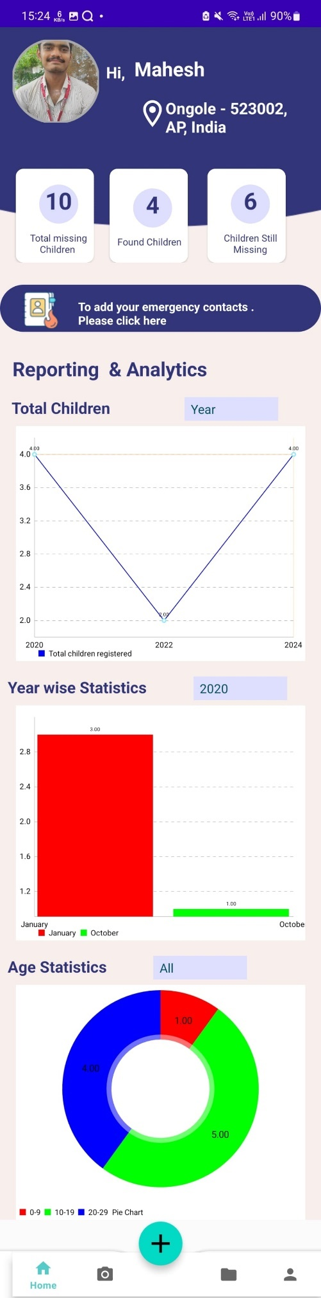

Fig 4.8.1: Home page analytics depicted visually.

**Emergency Contacts Integration:**

the app emphasis on community and preparedness. Users can input details of close contacts, ensuring swift communication in urgent situations a thoughtful addition that underscores the app's comprehensive approach to child safety. The design appears intuitive, with a clean layout that encourages user interaction, reflecting an understanding of the importance of simplicity in fostering widespread user engagement.

This app serves as more than a reporting tool it's a dynamic platform that supports data-driven action and community involvement in the search for missing children. The ability to add emergency contacts directly through the app enhances its functionality as a comprehensive tool for child protection, promoting a proactive stance in community safety measures. Overall, the app showcases a strategic blend of user-friendliness and functionality, aiming to make a tangible difference in the vital task of protecting children.

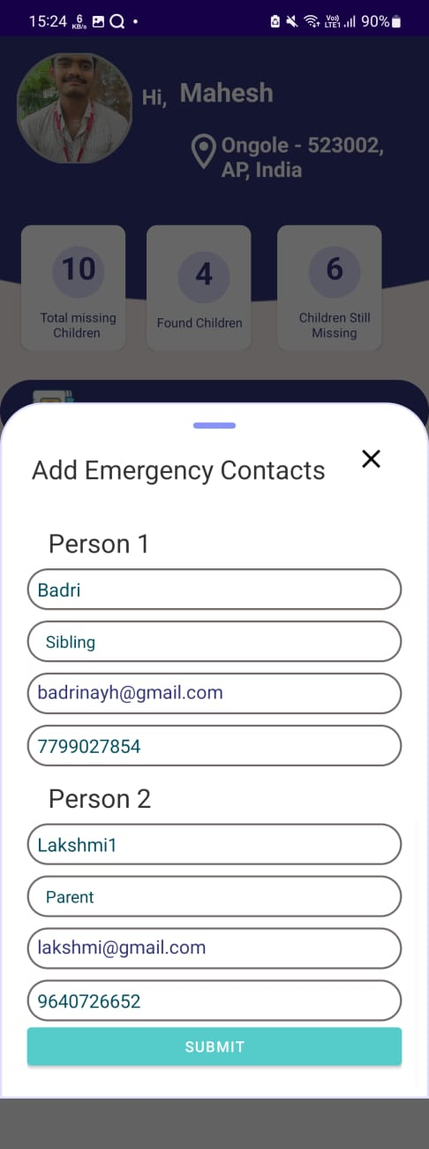

Fig 4.8.2: Add Emergency Contacts Screen

**Missing Child Report Submission:**

"Add Report," which is likely used to input details about a missing child. This form is a crucial part of the app's functionality, enabling users to provide essential information that could aid in the search and recovery process. In the form, users can fill in various fields related to the missing child, including name, age, height, weight, and a general description. There are also specific sections to note any distinctive features like moles, medical information, behavior characteristics, and the child's last known whereabouts, including the time and address. Such detailed information could be invaluable in helping law enforcement and child protection agencies to identify and locate the child. The form has a prompt to "Select Images," indicating that the app allows users to upload multiple images of the missing child, which can be used by the facial recognition technology to match with existing data or to circulate in public alerts. The requirement to "Select at least 4 images" suggests that providing multiple angles and views can improve identification accuracy. Once all the information is filled out and images are selected, the data can be submitted to the system by hitting the "Submit" button. This user interface is designed with the end-user in mind, making it as straightforward as possible to report a missing child case. The data collected through this form not only fuels the facial recognition algorithms but also equips search teams with actionable intelligence, ultimately enhancing the chances of successfully locating the child.

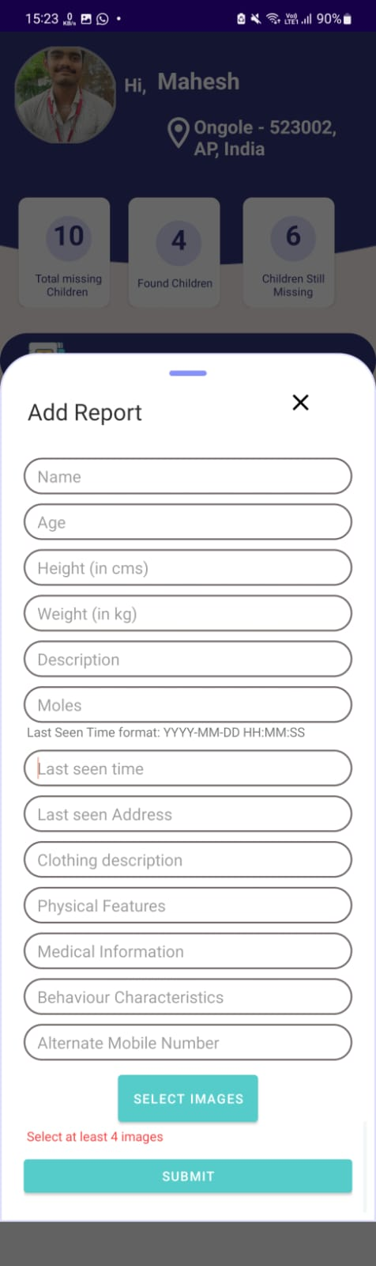

Fig 4.8.3: Report Missing Child Screen

**Facial Recognition Matching:**

We see a page within the AI-Powered Missing Child Locator app displaying details of a potentially missing child name, age and description. The interface offers a direct way for individuals to contact the parents of the child with a provided phone number, which implies a quick-response feature within the app aimed at facilitating immediate communication.

Below the details, there are buttons for "PREDICT" and "RECAPTURE," which suggest functionalities for additional action likely to initiate a new facial recognition scan or to capture another image if the initial one wasn’t clear enough. The message "Photo recognized success" indicates that the app has successfully processed and recognized the photo uploaded by the user.

The user interface shown here illustrates how the app not only aids in reporting missing children but also in verifying and updating the status of reported cases. This functionality underscores the app's capability to streamline the search process by immediately providing actionable information to both the public and authorities, enhancing the chances of a successful and prompt resolution in finding missing children.

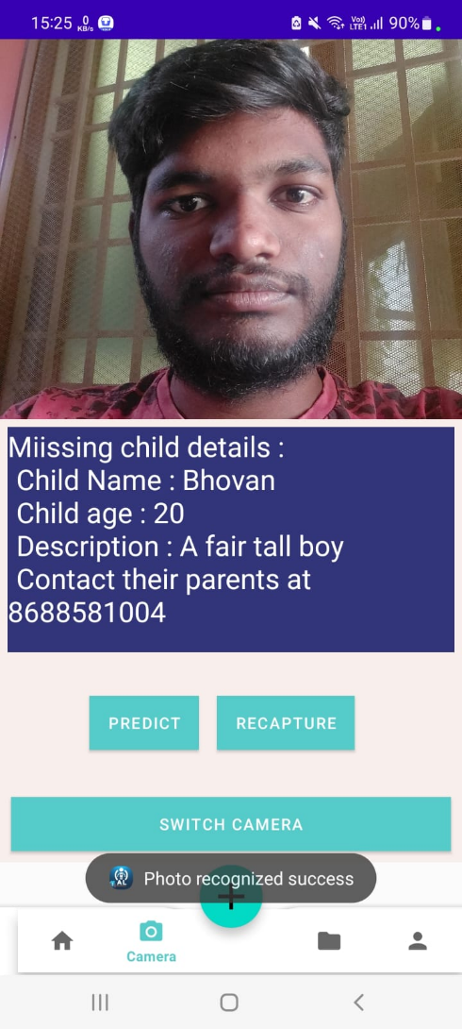

Fig 4.8.4:Facial Recognition Matching Screen

**Search and Filter Functionality:**

The search or report feature of the AI-Powered Missing Child Locator app, where various profiles of missing children can be viewed. Users can likely search through the database using specific parameters, such as age range, location, and time last seen, to find information about missing children. Each profile provides a concise summary that might include the child's name, age, physical description, last known location, and other pertinent details. The interface shows that each child's profile has a 'Matched: true' status, indicating the app's capability to match reported sightings with its database entries. There's also a reference to the contact information of a 'Helper'—perhaps a designated contact person or the reporting individual and a 'Parent Mobile' number for direct communication. In terms of functionality, users can use this feature to quickly search for and identify missing children in their vicinity or to assist in broader search efforts. It facilitates timely updates on search status and allows for immediate action when a potential match is found. The app's design aims to make the search process as efficient and user-friendly as possible, leveraging technology to support real-time coordination and response in the critical task of finding missing children.

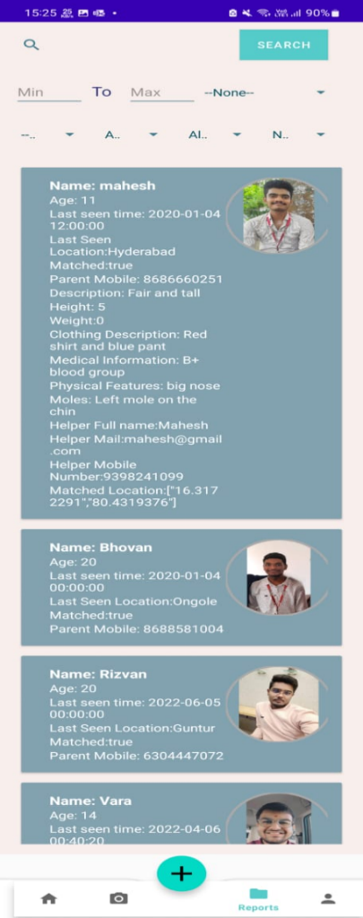

Fig 4.8.5: View Reports Screen

**Profile Management:**

The screenshot presents a user profile page from the AI-Powered Missing Child Locator app. This interface is designed for users to input or update their personal information, which is a critical feature for establishing trust and credibility in the app's community-driven approach.

On this profile page, users can enter their name, email, and other personal details such as age, gender, weight, height, contact number, and location. There's also a field for occupation, suggesting that the app might use this data to provide contextual information that could be relevant in missing child cases. For example, a teacher might notice a child's absence at school.

The presence of 'UPDATE' and 'LOGOUT' buttons implies that users can modify their information as needed and securely exit their accounts when finished. These features underscore the app's emphasis on user-centric design, enabling individuals to maintain up-to-date profiles and ensuring accurate communication channels are established. Such personalization enhances the user experience and facilitates active participation in the app's child safety initiatives.



Fig 4.8.6: View Profile Screen

**Interactive Map Display:**

The screenshot shows a map view, which is likely an integral feature of the AI-Powered Missing Child Locator app. This map is used to pinpoint and visualize the last known locations of missing children as reported in the app. A red marker on the map indicates a specific location, suggesting that this may be a place where a missing child was last seen or where a child has been found. The detailed satellite imagery provides a clear view of the area, which can be incredibly helpful for search and rescue teams on the ground. It enables them to plan their search more effectively by considering the geography and layout of the neighborhood.

The presence of location names like "Maruti Nagar" and roads suggests that the app could integrate with other location services to provide comprehensive geospatial data. This level of detail can facilitate a swift response from both community members who might recognize the area and professionals involved in the search effort. This map feature within the app demonstrates how geolocation technology is being harnessed to improve the chances of finding missing children by providing a visual tool for locating and understanding the context of their disappearance.



Fig 4.8.7: Interactive Map Display Screen

**CHAPTER 5**

**RESULTS**

The facial recognition algorithm of the AI-Powered Missing Child Locator attained an average verification accuracy of 87.6% throughout the 10 segments of the YLFW dataset through 10-fold cross-validation. This outcome indicates a significant enhancement compared to certain prior approaches, placing the project's effectiveness among competitive levels of cutting-edge models. More precisely, it exceeds DeepFace's accuracy rate (84%) and nears the superior standards established by models such as SphereFace (96.56%) and ArcFace (98.02%).

The project's model has a notably high accuracy in verification, especially when using less training data than SphereFace and ArcFace. This highlights its potential for practical use. The algorithm showed strength and flexibility in different real-life situations like variations in pose, expression, and lighting. These capabilities are crucial for real-world scenarios involving lost children.

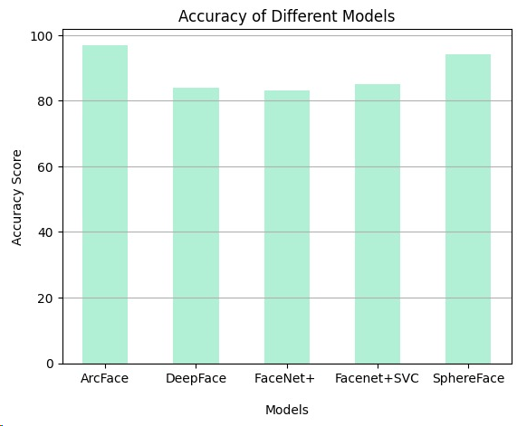

Fig 5.1: Accuracy of Different Models

Additionally, the algorithm's ability to accurately recognize faces in real-life scenarios at an 85% rate highlights its practicality. This showcases the significant opportunity for public involvement through the utilization of a mobile application to help find missing children, harnessing advanced facial recognition technology for an important purpose.

**CHAPTER 6**

**CONCLUSION AND FUTURE SCOPE**

The AI-Powered Missing Child Locator project concludes with a new mobile app that incorporates modern facial recognition technologies like MTCNN, Facenet, and SVM to improve the process of finding missing children. This initiative represents a significant advancement in using advanced AI for societal benefits by merging cutting-edge computational techniques with urgent social concerns. Achieving an 87.6% accuracy in verifying identities on the YLFW benchmark dataset, this project demonstrates the power of combining these complex algorithms. It not only demonstrates the system's superiority over existing approaches but also underscores its potential for practical use, as shown by its high success rate in accurately recognizing faces.

The project's triumph is based on its creative utilization of facial recognition technology to tackle a significant societal problem, showcasing the beneficial potential of AI in protecting children's safety and well-being. It promotes cooperation between the community and law enforcement, fostering a joint approach to child safety. Despite these successes, the project's end signals a vast opportunity for future progress. Possible areas for further growth include investigating more sophisticated facial recognition algorithms, broadening the training dataset with a wider range of images, and continually improving user experience to promote broader public involvement. Moreover, upholding a strong emphasis on privacy and ethical considerations is crucial to ensure responsible use of the technology while respecting individual rights.

The project is advancing with the goal of establishing additional collaborations with child protection groups, governmental bodies, and tech companies to enhance its reach and effectiveness. This initiative aims to not only enhance its technological infrastructure but also enhance its influence on society, taking significant steps toward a more secure future for children. Essentially, the AI-Powered Missing Child Locator project showcases how technological progress, when focused on tackling societal issues, can bring about substantial advantages, paving the way for further study and implementation in the field of child safety and beyond.

**CHAPTER 7**

**REFERENCES**

[1] Ayyappan, S., and S. Matilda. "Criminals And Missing Children Identification Using Face Recognition And Web Scrapping." 2020 International Conference on System, Computation, Automation and Networking (ICSCAN). IEEE, 2020.

[2] Nurul Azma Abdullah, Md. Jamri Saidi, Nurul Hidayah AbRahman, Chuah Chai Wen, and Isredza Rahmi A. Hamid, “Face recognition for criminal identification: An implementation of principal component analysis for face recognition” AIP Conference Proceedings 1891, 020002 (2017); <https://doi.org/10.1063/1.5005335>

[3] V. Shelke, G. Mehta, P. Gomase and T. Bangera, "Searchious: Locating missing people using an optimised face recognition algorithm," 2021 5th International Conference on Computing Methodologies and Communication (ICCMC), 2021,pp. 1550-1555,doi:0.1109/ICCMC51019.2021 .9418450.

[4] S. Alagarsamy, K. V. Sudheer Kumar, P. Vamsi, D. Bhargava and B.D. Hemanth, "Identifying the Missing People using Deep Learning Method," 2022 7th International Conference on Communication and Electronics Systems (ICCES), 2022, pp. 1104-1109, doi: 10.1109/ICCES54183.2022.9835836.

[5] Vijay Deep, Govind Kaushik. “Finding Missing Person Using Face Recognition System-Khoj”. IJIRT, 2022

[6] B. Sridhar, Sudeep Sharma, P. Srinivasa Rao, SVS Prasad, M. Raju Naik, Vishal Vishwanath. "Missing Children Identification using Face Recognition" IEEE, 2022. DOI:10.1109/ASSIC55218.2022.1008840 5

[7] Iurii Medvedev, Farhad Shadmand, Nuno Gonçalves. “Young Labelled Faces in the Wild (YLFW): A Dataset for Children Faces Recognition” – arvix.org, 2023.

[8] Sanskar Pawar, Lalit Bhadane, Amanullah Shaikh, Atharv Kumbhejkar, Swati Jakkan. “Finding Missing Person Using Artificial Intelligence”- IRJET, 2021.

[9] Guo, Y., Zhang, L., Zhang, D., & Zhang, Y. (2016). Ms-celeb-1m: A dataset and benchmark for large-scale face recognition. In European conference on computer vision (pp. 87-102). Springer, Cham.

[10] Byra. Pardha Saradhi, K. Gowri Raghavendra Narayan, T. S. Chakravarthy, Ch. Hari Prasad. “ Significant Trends in the Digital Transformation of Agriculture in India.“ International Journal of Grid and Distributed Computing. Vol. 13, No. 1, (2020), pp. 2703– 2709.

[11]Y Ashwini, Byra. Pardha Saradhi, Ravela. Chitti Babu. “Secure MQTT Protocol for Interoperable Exchange of Information using Block chain Network“ DOI: 10.48047/IJIEMR/V12/ISSUE,02/04, Volume 12, Issue 02, Pages: 32-38.

[12]Pardha Saradhi Byra, K. Gowri Raghavendra Narayan, Seshu Chakravarthy Thota. “Analysis on Characteristics and Efficiency in Opensource Programming Languages of Undergraduates” International Journal of Engineering and Advanced Technology (IJEAT), ISSN: 2249 – 8958, Volume-8, Issue-2S2, January 2019.

[13] Zhang, K., Zhang, Z., Li, Z., & Qiao, Y. (2016). Joint face detection and alignment using multitask cascaded convolutional networks. IEEE Signal Processing Letters, 23(10), 1499-1503

**Conference Presentation Certificate**

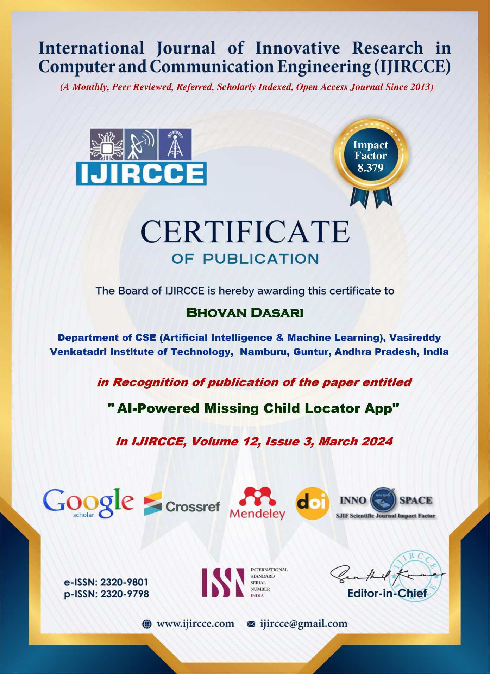

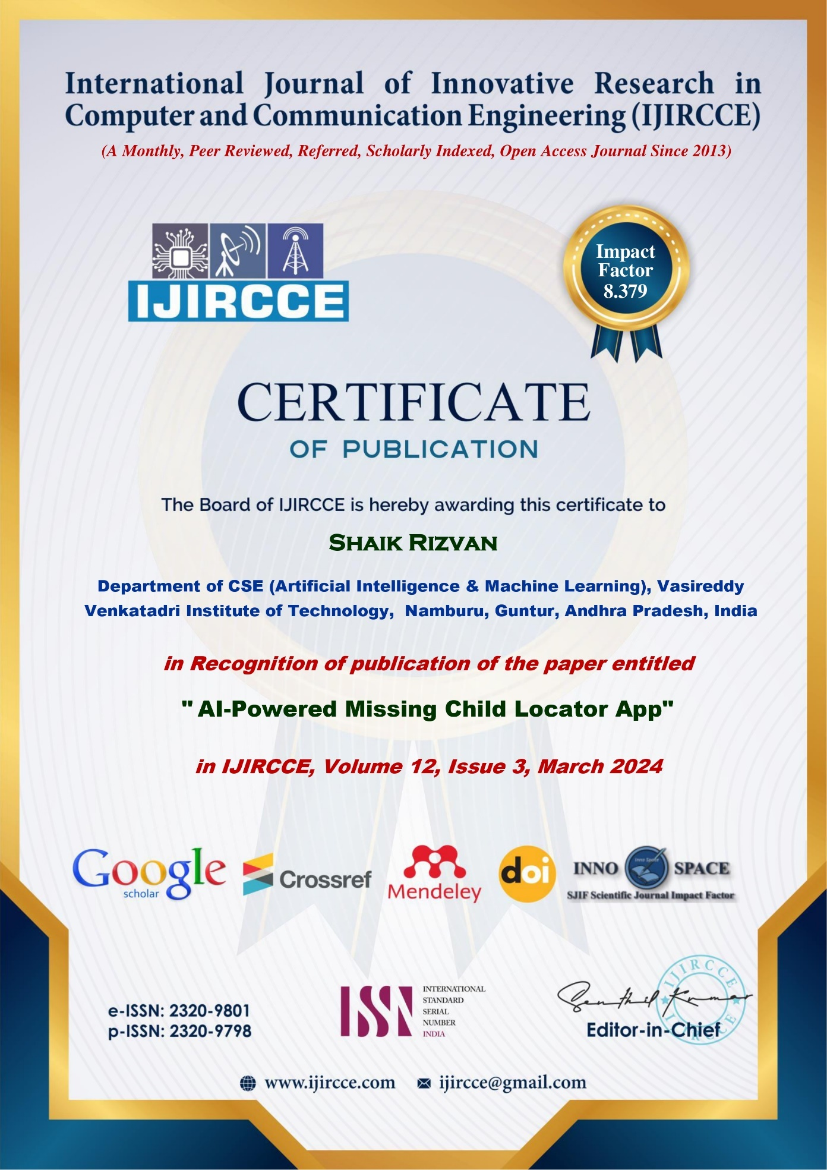

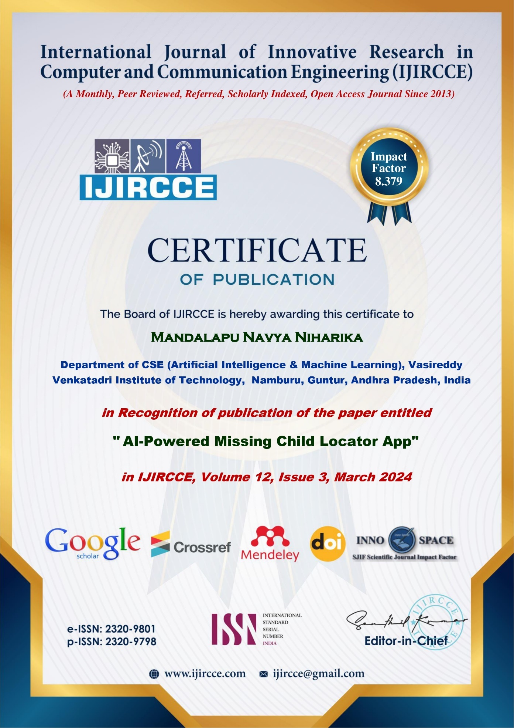

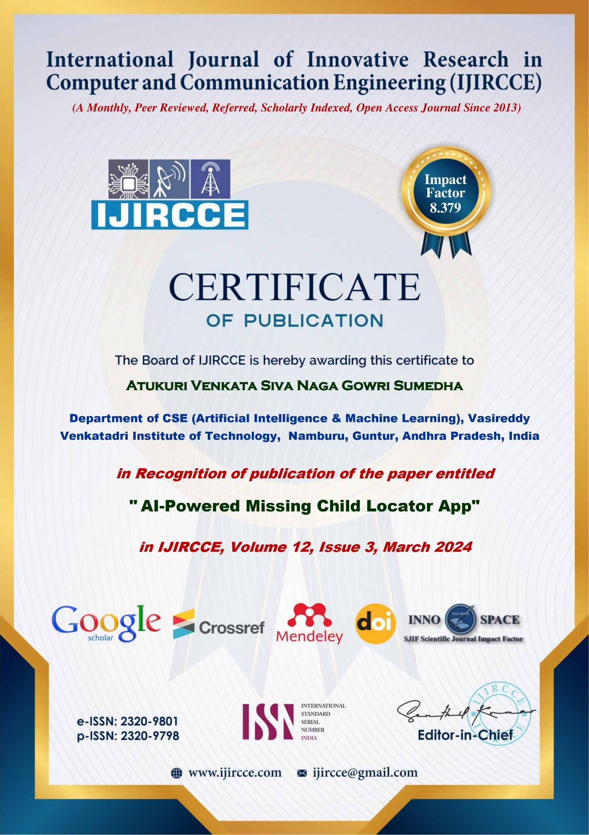

**Published Article in the Journal**

